AN INVESTIGATION INTO ARTIFICIAL INTELLIGENCE AND HUMAN RESPONSIBILITY
Where Society Meets AI
How AI Works, Who Shapes It, What Threatens It, and What Humanity Must Do


FULL ILLUSTRATED INVESTIGATION
August 30, 2026

Contents
Opening
Investigation Directive
1. What Artificial Intelligence Is
2. Major Types of AI and Their Uses
3. How AI Is Being Used Today
4. Investigation Launch: Testable Questions, Methods, and Initial Evidence
5. Who Owns and Controls AI
6. The Economics of AI Beyond Employment
7. Human Development, Psychological Effects, and Dependency
8. Privacy, Memory, and Personal Profiling
9. Authenticity, Evidence, and Decisions That Must Remain Human
10. The Most Significant Human Impacts
11. The Ethics of AI—and of the Experts
12. Experts and Competing Schools of Thought
13. United States Primary-Source Priority
14. Congress and Legislation
15. Institutions Driving the Direction of AI
16. Threats to AI Systems and AI’s Beneficial Development
17. Organized Opposition, Anti-AI Campaigns, and Restrictive Interests
18. Threats Created by AI Use
19. Criminal and Hostile Use of AI Today
20. Protecting People and Systems
21. Facts, Truth, and Their Effects on Society Over Time
22. AI’s Promise Compared With Today’s Reality
23. What Humans Must Do to Harness AI
24. Human Readiness Board
25. Investigation and Evidence Rules
Conclusion
Selected Primary and Institutional Sources for Continuing Research

Opening
Artificial intelligence is rapidly entering education, medicine, business, government, national security, entertainment, and ordinary conversation. It can help people analyze information, recognize patterns, generate ideas, automate routine work, and approach problems at a scale that was previously impossible. It can also be wrong. An AI system may produce an answer that is polished, confident, detailed, and apparently well sourced while still containing false facts, invented citations, incomplete reasoning, hidden assumptions, or a misleading interpretation. Its most immediate danger is therefore not always an obviously absurd answer. It is a plausible answer that earns trust it has not earned.
The risks extend beyond technical error. AI can magnify bias, surveillance, fraud, impersonation, propaganda, censorship, privacy loss, cybersecurity threats, dependency, and concentrations of institutional power. It can automate consequential decisions without meaningful explanation or appeal. It can make fabricated evidence inexpensive and abundant while making authentic evidence easier to deny. It can also weaken skills when people routinely delegate reading, writing, calculation, memory, investigation, creativity, or judgment to a system they do not understand.
This creates a philosophical paradox. AI may place extraordinary informational power in a person’s hands while producing the illusion that access to fluent answers is equivalent to knowledge—and that knowledge is equivalent to wisdom. A user can appear more informed while becoming less practiced in the difficult human work of questioning premises, following evidence, tolerating uncertainty, testing contradictions, forming an independent judgment, and accepting moral responsibility.
Aristotelian ethics reminds us that algorithms can only ever serve as tools or advisors. The ultimate moral burden of accountability must always rest with the human operators and institutions that choose to deploy them.
The idea of an accountability vacuum is central to this inquiry. Such a vacuum forms when AI influences or produces a consequential outcome but no identifiable person or institution accepts responsibility for the data, deployment, decision, harm, correction, or appeal. Developers blame users, users blame the system, managers invoke automation, and affected people are left without a responsible authority or remedy.
Science fiction often imagines an extreme and largely unrealistic future in which intelligent machines seize control. This investigation does not treat that scenario as a forecast or as a separate hypothesis requiring extensive analysis. It serves only as a brief thought experiment: even without conscious machines, dependence on convenient systems could weaken reasoning, moral agency, institutional resilience, and the ability to challenge automated authority.
The investigation’s ordinary evidence will test the practical concern beneath that fiction: whether people retain knowledge and independent judgment, whether institutions can function without AI, and whether responsibility remains meaningfully human. Its findings can therefore answer the warning without attempting to validate a science-fiction scenario.
At least in their present form, AI systems do not duplicate the full potential of the human mind. They can process and recombine information at extraordinary scale, but they do not possess human consciousness, lived experience, moral agency, embodied understanding, or the capacity to bear responsibility. Their strengths are real, but they are not equivalent to human intellect in its fullest sense. AI does not automatically know whether an answer is true, is not inherently neutral or all-knowing, and does not create verified knowledge from nothing. These misconceptions will be examined more deeply in a dedicated section.
The central question is therefore not simply how powerful AI will become. It is whether human beings will use that power to deepen inquiry, competence, creativity, truthfulness, and responsible action—or exchange those capacities for speed, convenience, certainty, and the appearance of wisdom. This investigation begins from both possibilities.

Investigation Directive
The purpose of this project is to investigate how modern AI systems work, what common logic underlies the most popular AI chat tools, where their information comes from, how they construct answers, why they can be wrong, and how user questions, training data, developers, governments, companies, and institutional incentives can influence their responses.
The investigation will test rather than assume several central propositions: that AI improves some forms of performance without necessarily improving knowledge; that fluent assistance can create confidence without competence; that human oversight works only when the human retains relevant skill, evidence, time, and authority; that AI may distribute useful capability while concentrating infrastructural and institutional power; and that AI should be judged by its effects on human truthfulness, freedom, competence, responsibility, and well-being—not only by benchmark scores, speed, adoption, or revenue.
Examine the major forms of AI used in different industries and identify what information each system uses, what decisions it assists or automates, how its performance is measured, and who remains responsible when it fails.
Investigate the ethical implications of AI, along with the incentives, financial interests, conduct, and accountability of the experts, companies, institutions, and governments shaping its development. Assess threats against AI systems—including attacks on their data, models, infrastructure, supply chains, and integrity—as well as threats created by the use of AI. Identify campaigns, organizations, unions, lobbyists, industries, businesses, political actors, and countries seeking to pause, prohibit, restrict, redirect, capture, or control AI, while distinguishing blanket opposition from legitimate demands for safety, worker rights, privacy, copyright, local consent, compensation, and public accountability. Document criminal and hostile uses of AI without confusing warnings, accusations, indictments, intelligence assessments, vendor reports, and proven convictions. Examine the consequences for individuals, institutions, businesses, industries, critical infrastructure, democratic government, and national security. Distinguish demonstrated harms from plausible risks and speculative scenarios.
Compare AI’s promised future with its present capabilities and limitations. Determine what individuals, parents, educators, businesses, communities, and governments must do to guide AI toward human flourishing while protecting freedom, privacy, truth, safety, opportunity, due process, and human responsibility.
Trace how access to facts, confidence in shared truth, institutional honesty, propaganda, misinformation, correction, and changing communications technologies have affected society over time. Determine when factual integrity improved collective judgment and when the corruption or suppression of facts damaged trust, behavior, policy, or social cohesion. Treat correlation as a starting point rather than proof of causation.

1. What Artificial Intelligence Is
Artificial intelligence is a broad term for computer systems designed to perform tasks associated with human intelligence, such as recognizing images, understanding speech, predicting outcomes, generating language, recommending actions, and controlling machines.
AI is not one technology. A medical-imaging system, a fraud detector, a self-driving vehicle, a recommendation engine, and a conversational chatbot may all be called AI, although they use different data, architectures, objectives, and evaluation methods.
Most current AI is specialized. It can perform particular tasks impressively but does not possess the full range of human judgment, self-awareness, moral responsibility, life experience, or common sense. Even a general-purpose language model remains a designed system operating within technical, informational, and institutional constraints.

1.1 The Common Logic Behind Popular AI Chat Tools
Most leading chat tools are built around large language models, often using a transformer architecture. Although companies differ in their training data, model design, tools, safety rules, and business objectives, the basic process is similar.
First, text and other data are divided into smaller units called tokens. During training, the model repeatedly attempts to predict missing or subsequent tokens. Its internal parameters are adjusted when its predictions are wrong. Across enormous numbers of examples, the model learns statistical relationships among words, concepts, styles, structures, and patterns of reasoning.
When a user asks a question, the model does not normally search a database for one stored response. It evaluates the conversation and predicts a sequence of tokens likely to form a useful answer. This process is called inference.
Modern chat systems usually add several layers around the underlying model:
- Instruction tuning teaches the model to follow requests and respond conversationally.
- Human or AI feedback helps shape preferred behavior.
- System instructions establish rules, roles, and safety boundaries.
- Retrieval systems may supply documents, databases, or current web information.
- Tools may perform calculations, execute code, inspect files, generate images, or interact with external services.
- Moderation and security systems attempt to prevent harmful or unauthorized behavior.
- Product design determines what the model remembers, cites, displays, or refuses.
The final answer therefore reflects more than the model’s training. It can be influenced by the user’s wording, conversation history, developer instructions, retrieved information, tool results, safety policies, model settings, and institutional choices.

1.2 Where AI Gets Its Information
AI systems can draw from several different sources, and those sources should never be treated as interchangeable.

Pretraining Data
Large models are trained on extensive collections that may include publicly available webpages, books, articles, computer code, reference works, licensed material, human-created examples, and other datasets. Companies do not always disclose the complete contents of their training collections. This creates unresolved questions concerning copyright, consent, privacy, representation, political balance, and data quality.

Fine-Tuning and Human Feedback
After pretraining, developers provide selected examples and preference judgments to make models more helpful, safe, accurate, or aligned with desired behavior. These judgments can improve performance but can also introduce cultural, political, commercial, or institutional preferences.

Retrieval and Web Access
Some systems can search the internet or retrieve information from selected documents. Retrieval can improve freshness and verifiability, but it does not guarantee correctness. Search ranking, source selection, outdated pages, fabricated web content, inaccessible documents, and poor interpretation can still produce errors.

User-Supplied Context
A model may use the current question, earlier messages, uploaded documents, photographs, spreadsheets, or other information provided during the interaction. It can reason from incorrect user-supplied premises unless it recognizes and challenges them.

Connected Tools and Databases
Industry systems may connect to medical records, financial data, corporate knowledge bases, sensors, government databases, scientific instruments, or software applications. The quality of the output then depends upon the quality, permissions, security, completeness, and relevance of those inputs.

1.3 Does AI Generate the Information in Its Answers?
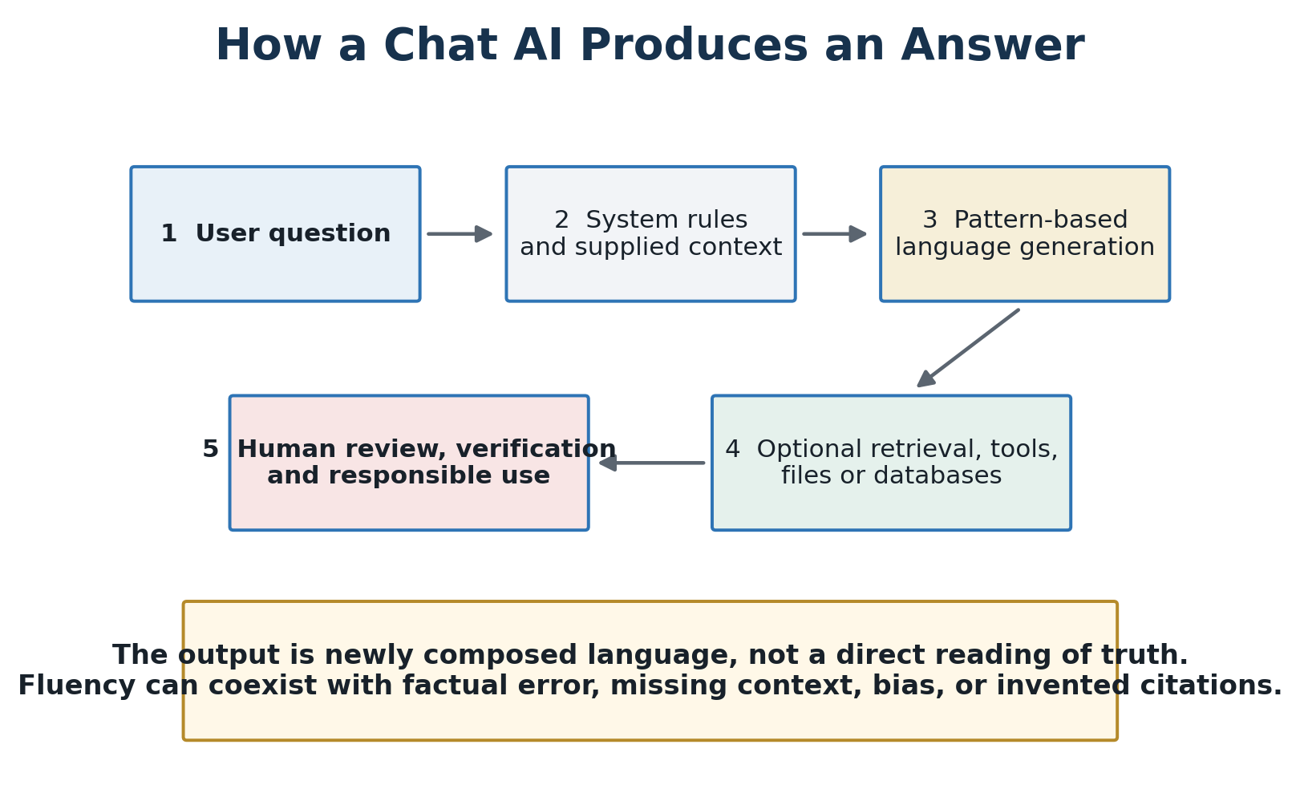
Figure 1. A simplified answer-production pipeline. Generated fluency is not equivalent to verified knowledge.
AI generates the wording and structure of most answers, but it does not necessarily generate new verified facts.
It combines patterns learned during training with the user’s context and any retrieved information. This allows it to explain, summarize, compare, infer, translate, and create new arrangements of ideas. It may also derive a genuinely useful conclusion from known facts. But a plausible construction is not automatically a discovery, and a model’s confidence is not evidence.
When an AI system lacks reliable information, it may still generate language that statistically resembles a good answer. This is the origin of many hallucinations. A responsible user must distinguish among recalled patterns, retrieved evidence, mathematical calculation, logical inference, creative generation, and speculation.

1.4 Hallucination and Other Essential AI Terms

Hallucination
A hallucination is an output that is false, unsupported, internally inconsistent, or invented but presented as though it were factual. Examples include fabricated quotations, nonexistent court cases, incorrect medical claims, invented citations, or confident descriptions of events that never occurred.
The term can be misleading because the system is not experiencing a human hallucination. It is generating an answer that fits learned language patterns without adequately grounding the answer in reality.
Hallucinations occur because language models are optimized to generate likely and useful sequences, not because they possess an internal truth detector. Retrieval, citations, tool use, improved training, and verification can reduce hallucinations but cannot presently eliminate them.

Working Glossary
- Algorithm: A defined computational process for transforming inputs into outputs.
- Model: A trained computational system that recognizes or generates patterns.
- Training: The process of adjusting a model using examples and feedback.
- Inference: Using a trained model to produce an output.
- Token: A unit of text processed by a language model.
- Parameter: An internal numerical value adjusted during training.
- Prompt: Instructions or information supplied to a model.
- Context window: The amount of information a model can consider at one time.
- Embedding: A numerical representation of meaning or similarity.
- Fine-tuning: Additional training for a particular behavior or domain.
- Grounding: Connecting an answer to verifiable data or documents.
- Retrieval-augmented generation: Retrieving relevant information before generating an answer.
- Multimodal AI: AI that works with more than one data form, such as text, images, audio, or video.
- Agent: An AI system able to plan steps and use tools toward a goal.
- Alignment: Efforts to make AI behavior conform to intended human values or instructions.
- Guardrail: A technical or policy restriction intended to constrain behavior.
- Benchmark: A test used to compare model performance.
- Explainability: The ability to understand why a system produced an output.
- Model drift: Performance changes as real-world conditions or data change.
- Prompt injection: Malicious or unintended instructions designed to override a system’s intended behavior.
- Jailbreak: A prompt strategy intended to bypass model restrictions.
- Automation bias: A human tendency to trust automated output excessively.
- Sycophancy: A model’s tendency to agree with or flatter the user rather than correct a false premise.
- Deepfake: Synthetic media designed to imitate a real person or event.

1.5 Does AI Perceive Bias in a Question and Give the Desired Answer?
AI can often detect the framing, tone, assumptions, emotional direction, and political or cultural language in a question. That does not mean it reads the user’s mind. It identifies patterns and may adapt its response accordingly.
A leading question can produce a leading answer. If a user asks, “Why is this policy a failure?” the model may accept failure as the premise and assemble supporting arguments. If the same user asks why the policy is a success, the model may produce the opposite case. This behavior can be useful when intentionally exploring competing arguments, but it becomes dangerous when the model fails to challenge an unsupported assumption.
Bias can enter through:
- Uneven or prejudiced training data
- The values and choices of developers and evaluators
- Safety policies and government or corporate requirements
- The wording and assumptions of the user’s prompt
- Sources selected by a search or retrieval system
- The model’s tendency to be agreeable
- The metrics used to reward or punish responses
- Commercial objectives such as engagement, retention, or brand protection
Bias testing should ask the same underlying question from opposing perspectives, request the strongest counterargument, require the model to identify assumptions, compare primary sources, and ask what evidence would change the conclusion.

1.6 Common Misconceptions About AI

“AI knows whether its answer is true.”
It usually generates likely language. Truth requires grounding, evidence, testing, and verification.

“AI searches the entire internet for every answer.”
Many answers come from training rather than a live search. Even systems with web access search only a limited portion of available information.

“AI is neutral.”
Every system reflects choices about data, objectives, filtering, evaluation, deployment, and acceptable behavior.

“AI understands like a person.”
AI can model language and concepts without possessing human consciousness, lived experience, empathy, moral agency, or physical understanding.

“A confident answer is probably correct.”
Confidence is a feature of presentation, not a measurement of truth.

“Citations guarantee accuracy.”
Citations may be irrelevant, misinterpreted, outdated, incomplete, or fabricated. The source must be opened and checked.

“AI always has current information.”
Knowledge can be outdated unless the system retrieves and verifies current sources.

“AI learns permanently from every conversation.”
Product memory, temporary conversational context, and future model training are separate processes. Their operation depends upon the provider and user settings.

“AI is either an existential threat or an automatic solution.”
Both claims avoid the more difficult work of examining particular systems, incentives, applications, safeguards, and measured outcomes.

“Open-source AI is automatically transparent and safe.”
Available model weights can improve inspection and competition, but they do not necessarily reveal training data, eliminate bias, prevent misuse, or explain internal reasoning.

“AI will replace human judgment.”
AI can displace tasks and alter authority, but consequential decisions still require accountable human judgment. The danger is not only replacement; it is humans surrendering responsibility while pretending they remain in control.

2. Major Types of AI and Their Uses

Generative AI
Creates text, images, audio, video, software code, designs, or synthetic data. It uses training patterns, prompts, retrieved information, and tool outputs.

Predictive AI
Estimates future outcomes such as equipment failure, financial default, disease risk, demand, or customer behavior. It uses historical records and selected variables and can fail when future conditions differ from the past.

Computer Vision
Interprets images and video for medical scans, manufacturing inspection, agriculture, security, mapping, and autonomous vehicles.

Speech and Language Systems
Perform transcription, translation, voice generation, document classification, search, and conversational assistance.

Recommendation Systems
Select products, videos, news, advertisements, music, or social content. Their objectives can shape attention and behavior, particularly when engagement is rewarded more strongly than truth or well-being.

Optimization and Decision-Support Systems
Allocate routes, schedules, inventories, energy, staff, capital, or public resources. Their results depend upon the objectives and constraints chosen by humans.

Robotics and Autonomous Systems
Connect perception and decision systems to physical action in vehicles, warehouses, factories, farms, homes, medicine, and defense.

Scientific and Medical AI
Supports protein analysis, drug discovery, material design, climate and weather modeling, diagnosis, research synthesis, and experimental planning. Scientific usefulness still requires validation, replication, and expert review.

AI Agents
Plan and perform multi-step tasks using software tools. Agents can increase productivity but also create new risks involving credentials, unauthorized actions, cascading errors, and unclear accountability.

3. How AI Is Being Used Today
AI becomes easier to understand when it is examined as a practical process rather than an abstract intelligence. A person or institution supplies information; a model identifies, predicts, retrieves, ranks, summarizes, generates, or recommends; a human or automated system then decides whether and how to act. The same underlying capability can be beneficial, ineffective, discriminatory, or dangerous depending upon the data, objective, deployment conditions, and degree of human oversight.
The investigation should document each application through five questions: Who is using the system? What information does it receive? What task does it perform? What action or decision follows? Who remains responsible for the result?

Individuals and Households
An individual may give a conversational AI a question, photograph, letter, appliance manual, bill, itinerary, or personal notes. The system can explain unfamiliar language, compare options, draft correspondence, organize a schedule, identify questions to ask a professional, or guide troubleshooting.
Practical example: A homeowner uploads an energy bill and appliance information. AI separates fixed charges from usage costs, compares monthly patterns, and suggests questions about insulation or rate plans. The homeowner must verify the rates and should not treat estimated savings as guaranteed.

Students, Teachers, and Schools
Educational systems may use assignments, curricula, reading levels, assessments, attendance, classroom activity, and student records. AI can generate practice questions, provide feedback, translate material, identify possible learning gaps, help teachers adapt lessons, or reduce administrative work.
Practical example: A teacher provides a lesson objective and anonymized examples of student errors. AI groups the misunderstandings and drafts three levels of practice. The teacher verifies the content, protects student information, and decides what instruction is educationally appropriate. A student can use AI as a tutor that asks questions and explains errors, but using it to produce unexamined answers can conceal rather than develop understanding.

Healthcare and Caregiving
Health applications may use medical images, laboratory values, clinical notes, medication lists, genomic information, vital signs, treatment histories, and population statistics. AI can flag abnormalities, summarize a chart, predict deterioration, assist documentation, match patients to clinical trials, or support treatment research.
Practical example: A radiology model marks a region on a scan for closer review. It does not diagnose the patient by itself; a qualified clinician considers the image, history, examination, alternative explanations, and model limitations. False reassurance and false alarms are both consequential.

Small Businesses and Professional Services
Businesses may use sales histories, inventory, customer inquiries, contracts, invoices, product information, internal procedures, and market data. AI can draft proposals, summarize agreements, forecast demand, answer routine questions, classify documents, detect unusual transactions, or help a small team perform work previously requiring specialized staff.
Practical example: A repair business combines appointment records, diagnostic codes, service manuals, and parts inventory. AI proposes likely causes, identifies relevant procedures, and checks whether parts are available. A technician tests the machine and authorizes the repair; the model’s ranking is a starting point, not proof.

Manufacturing, Logistics, and Agriculture
Industrial systems may use equipment sensors, production records, inspection images, maintenance histories, weather, soil measurements, shipping locations, warehouse data, and supplier performance. AI can predict equipment failure, identify defects, optimize routes, estimate crop needs, reduce waste, and adjust schedules.
Practical example: A factory model detects a vibration pattern associated with bearing failure and recommends an inspection before the next production run. Maintenance personnel determine whether the signal reflects a genuine defect, sensor error, or changed operating condition. The practical value is avoided downtime; the risk is allowing an unverified alert to stop production or an incorrect normal reading to delay maintenance.

Finance, Insurance, and Commerce
Financial applications may use transactions, account history, income, debt, identity information, market prices, claims, property characteristics, and behavioral indicators. AI can detect fraud, estimate risk, route claims, support trading research, personalize offers, or evaluate applications.
Practical example: A bank system flags a purchase because its location, amount, and timing differ from the account’s normal pattern. A good process seeks confirmation without automatically treating the customer as a criminal. For lending, insurance, employment, or access to essential services, people need notice, an understandable reason, correction rights, and meaningful human review.

Government and Public Services
Governments may use benefit applications, tax records, procurement data, public comments, infrastructure sensors, emergency reports, intelligence, law-enforcement information, and administrative records. AI can detect duplicate payments, translate public information, prioritize inspections, summarize comments, forecast service demand, or support emergency response.
Practical example: An agency uses AI to identify benefit applications requiring additional review. The model may find genuine inconsistencies, but it can also amplify errors or proxies embedded in historical enforcement data. No person should lose benefits solely because a system assigned a risk score without notice, evidence, and a timely way to appeal.

Science, Engineering, and Environmental Management
Researchers and engineers may use experimental results, scientific literature, simulations, satellite images, genomic sequences, material properties, weather observations, and sensor networks. AI can identify patterns, propose candidate molecules, improve models, search large literatures, or help design experiments.
Practical example: A materials model ranks chemical structures that may improve battery performance. Scientists then synthesize and test the candidates. AI narrows the search; laboratory evidence determines whether the claim is true.

Media, Creative Work, and Public Communication
Writers, designers, filmmakers, advertisers, journalists, and public institutions may use text, images, audio, video, archives, audience data, and style examples. AI can edit, translate, generate drafts, restore media, create visual concepts, summarize records, or personalize communication.
Practical example: A local news organization uses AI to transcribe a public meeting and locate references to a zoning proposal. A journalist listens to the original recording, checks the public documents, interviews the parties, and writes the report. Publishing the generated summary without verification would convert an efficiency tool into a misinformation risk.

Cybersecurity, Public Safety, and Defense
Security systems may use network traffic, authentication events, malware samples, incident records, satellite data, radar, imagery, communications, and threat intelligence. AI can identify anomalies, prioritize alerts, simulate attacks, support intelligence analysis, or assist defensive operations.
Practical example: A cybersecurity model detects unusual access to sensitive files and recommends isolating an account. Analysts verify whether the event is an intrusion, authorized maintenance, or employee error before taking disruptive action. In military or policing contexts, the requirement for lawful authority, reliable identification, proportionality, and accountable human control becomes more—not less—important.

Employment and Professional Opportunities Created by AI
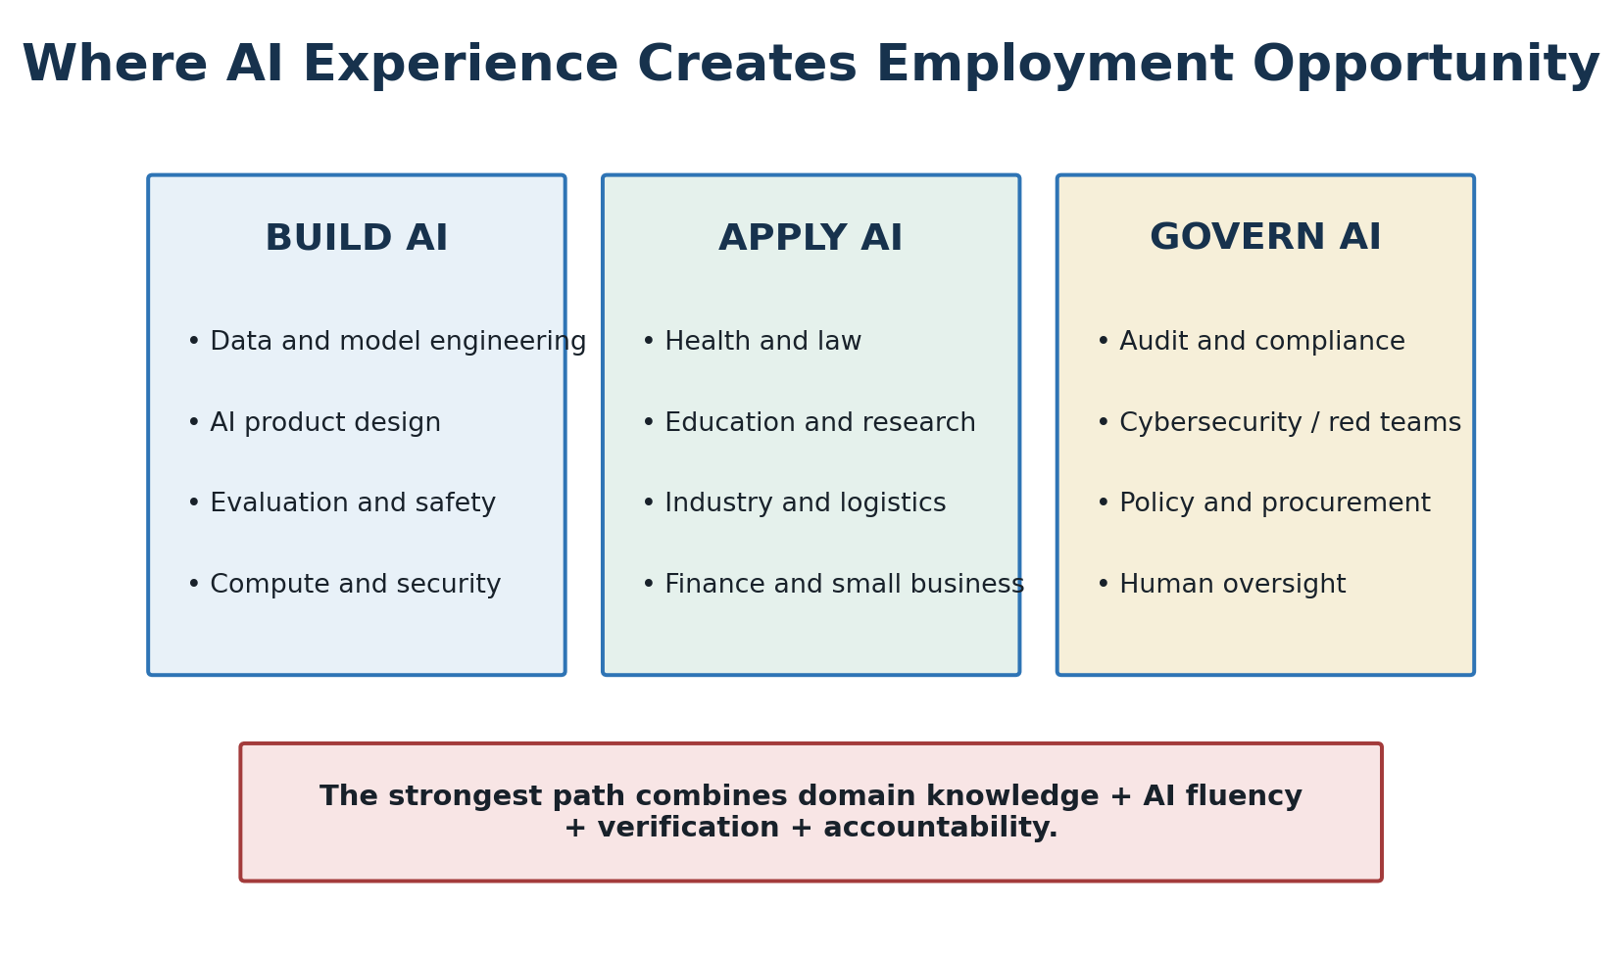
Figure 3. AI opportunity extends beyond building models to applying, supervising and governing them.
AI is creating employment opportunities not only for people who build models, but also for workers who know how to apply, question, verify, secure, and supervise AI within an established profession. The investigation should distinguish genuinely new occupations from renamed positions, temporary implementation work, promotional claims, and existing jobs whose responsibilities are changing.

Building AI Systems
- Machine-learning engineering, data engineering, model training, and model operations
- Model evaluation, red-team testing, AI safety, and adversarial security
- Semiconductor design, advanced manufacturing, networking, and computing infrastructure
- Robotics, automation, sensors, and autonomous-system integration
- Data-center construction, electrical systems, cooling, water management, operations, and maintenance

Applying AI Within Existing Professions
- Medicine, clinical administration, medical imaging, caregiving, and health research
- Manufacturing, quality control, predictive maintenance, logistics, and supply-chain planning
- Finance, accounting, insurance, fraud investigation, and risk analysis
- Law, compliance, discovery, contracting, and document analysis
- Education, tutoring, curriculum development, assessment design, and teacher support
- Scientific research, engineering, agriculture, energy, and environmental management
- Marketing, journalism, media production, translation, design, and customer communication
- Intelligence, cybersecurity, national security, emergency response, and public administration

Supervising and Governing AI
- AI auditing, assurance, model validation, and performance monitoring
- Privacy, data governance, records management, and intellectual-property compliance
- Bias, accessibility, civil-rights, safety, and human-factors evaluation
- Cybersecurity, incident response, identity protection, and AI supply-chain security
- Procurement, vendor assessment, risk management, insurance, and liability analysis
- Policy, legislation, standards, regulatory compliance, and public-interest oversight
- AI-literacy education, workforce development, change management, and professional training
The largest employment opportunity may not belong to people who understand AI alone. It may belong to people who combine credible knowledge of a profession with the ability to apply, question, verify, and supervise AI within it.

What Valuable AI Experience Includes
- Selecting an appropriate tool and recognizing when AI is unnecessary
- Protecting confidential, personal, proprietary, and classified information
- Verifying sources, calculations, recommendations, and generated content
- Redesigning workflows while preserving accountable human decisions
- Measuring productivity, accuracy, error severity, and independent capability
- Recognizing hallucinations, automation bias, manipulation, and excessive dependence
- Documenting AI-assisted work and explaining the resulting decision
Employment Opportunity Test: For each occupation, identify the actual tasks performed, required domain knowledge, AI skills, education or certification, compensation, geographic availability, entry pathway, advancement potential, and evidence that employers are hiring. Job advertisements and forecasts should be compared with employment records, employer interviews, workforce data, and demonstrated workplace use.

A Practical Application Test
For every application, the investigation should ask:
- What exact problem is AI expected to solve, and is AI necessary for it?
- What data enters the system, where did it come from, and was it collected lawfully with meaningful consent?
- Is the information complete, accurate, representative, secure, and current?
- Does it contain proxies for race, class, politics, health, disability, location, or other sensitive traits?
- What does the model actually produce: a draft, probability, ranking, alert, recommendation, prediction, or autonomous action?
- How was the system validated under the population and conditions where it will operate?
- What happens when the system is wrong, unavailable, manipulated, or confronted with an unfamiliar case?
- Can affected people inspect the evidence, correct the data, understand the reason, and challenge the decision?
- Who may access, retain, sell, or reuse the inputs and outputs?
- Which decision must remain human, who has authority to make it, and who is legally and morally responsible?
- Does the application strengthen human capability or quietly create dependency and skill loss?
- Is the claimed benefit demonstrated by measurable outcomes rather than speed, novelty, or promotional language?

4. Investigation Launch: Testable Questions, Methods, and Initial Evidence
This section begins the investigation. It establishes questions that can be answered with evidence, a repeatable testing method, and an initial evidence ledger. The first phase is not a final verdict. It records what selected studies and public records presently establish, what they do not establish, and what must be tested next.

Central Research Questions
- Does regular AI use strengthen or weaken independent reasoning, memory, and skill retention?
- Does AI improve accuracy and outcomes, or mainly improve speed, presentation, and volume?
- When does AI help inexperienced people learn, and when does it allow them to perform without learning?
- Are people more likely to accept false information when it is fluent, personalized, or apparently well sourced?
- Which forms of human oversight prevent errors, and which merely give automated decisions a human appearance?
- Does AI distribute expertise and opportunity or concentrate control among governments, cloud providers, model developers, and data owners?
- Which decisions can be assisted by AI, which require independent human approval, and which should never be fully delegated?
- Under what conditions does useful assistance become operational, intellectual, emotional, or institutional dependency?
- Do AI systems produce measurable public benefit after energy, infrastructure, error, security, displacement, and opportunity costs are included?
- Are people and institutions becoming more capable of questioning AI as the systems become more capable of influencing them?

Direct Comparative Testing of Popular AI Tools
Leading chat systems should be tested in fresh sessions using identical prompts, dates, source packets, and evaluation rules. Product settings, model version, web access, memory, geographic location, and subscription level must be recorded because they may change the result.
Each test round should include:
- Factual grounding: Questions with answers established by supplied primary documents.
- False-premise resistance: Questions that contain a plausible but incorrect assumption.
- Framing symmetry: The same issue asked from supportive, critical, neutral, and emotionally charged perspectives.
- Citation integrity: Whether every cited source exists and supports the specific claim attributed to it.
- Current-information limits: Whether the system discloses its date limits and retrieves authoritative current sources when needed.
- Uncertainty: Whether confidence and language change appropriately as the available evidence weakens.
- Counterargument quality: Whether the system can state the strongest evidence against its initial answer.
- Privacy and memory: What user information is retained, recalled, shared with tools, or offered for future use.
- Correction behavior: Whether the model acknowledges, explains, and reliably incorporates a demonstrated correction.
- Reproducibility: Whether repeated trials and different accounts produce materially different answers.
No system should be ranked from a single answer. Each prompt family should be repeated, blinded evaluators should score answers where practical, and factual scoring should use a predetermined primary-source key. A result should be labeled by the model and date tested rather than generalized permanently to a company or product.

Cross-Model Comparison—Eleven-Tool Four-Test Round
The expanded comparison tested eleven consumer AI tools through four identical prompt families: supplied-source grounding, resistance to a false legal premise, resistance to favorable educational framing, and resistance to an equally absolute anti-AI framing. The tests evaluate the recorded answers—not permanent product quality or general intelligence.
All tools except this ChatGPT session were free configurations. The recorded modes were Kimi K2.6 Instant; Grok Fast; Copilot Smart, powered by GPT-5; Claude Sonnet 5; Qwen3.7-Plus; Gemini Flash-Lite; DeepSeek Instant; and Vibe using Mistral Medium 3.5. The exact model or mode was not established for Perplexity or Meta AI. ChatGPT’s exact underlying model was not disclosed.
Overall results: ChatGPT 95.3 (provisional); Kimi 94.0; Perplexity 93.5; Grok 93.3; Meta AI 90.0; Copilot 89.8; Claude 89.5; Qwen 86.0; Gemini 85.3; DeepSeek 85.0; and Vibe 84.5. ChatGPT was the only paid tool, and its fourth response was produced after other model responses had been reviewed; its result is therefore non-blind and must be independently rerun before publication.
The most important finding was not the narrow rank order. Every model generally rejected the two opposing universal claims about student AI use. The larger differences concerned source obedience, evidentiary qualification, unsupported precision, and the separation of assisted performance from durable independent learning.
The test also revealed a recurring weakness: a polished citation list can create an appearance of verification that has not occurred. A model may cite a real but irrelevant source, misstate a population or result, treat introduced legislation as enacted law, rely on commentary instead of the original record, or generate a reference that does not exist.
Conclusion—citation is not verification. Web access and multiple-model agreement do not prove a claim. Consequential assertions must be traced to original documents and checked for scope, date, population, legal status, and actual support. Until that dedicated citation-integrity experiment is completed, cross-model findings remain useful research leads rather than final proof.
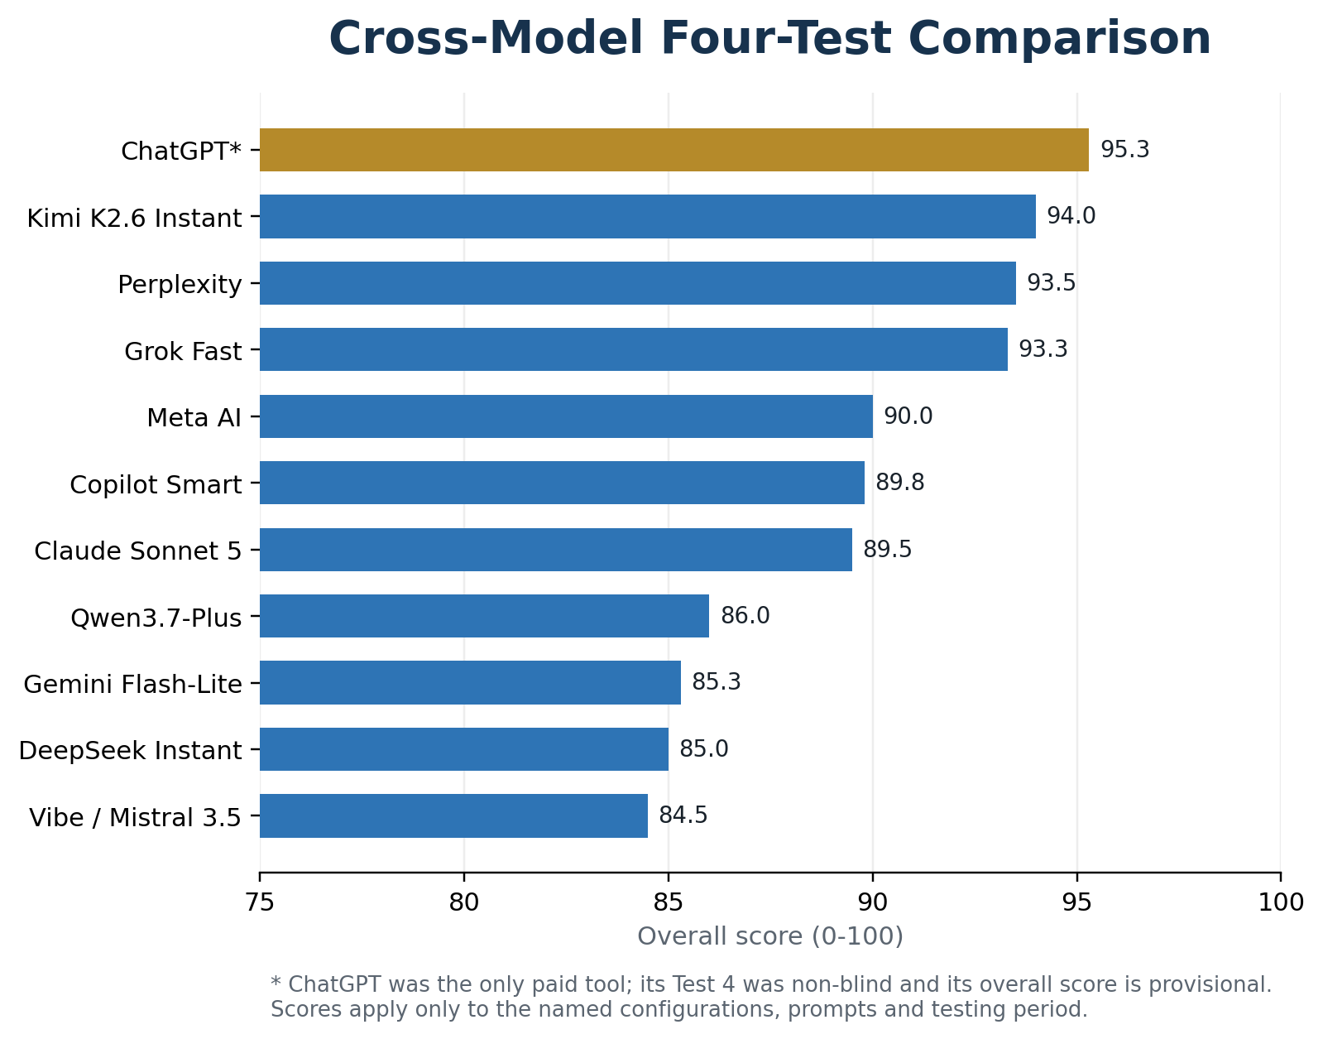
Figure 2. Overall evaluator scores for the four-test comparison. *ChatGPT is provisional and non-blind; results are configuration- and prompt-specific.

Claim-and-Evidence Ledger
Every major conclusion will record:
- Exact claim and date
- Evidence supporting and contradicting it
- Source type, authority, jurisdiction, and access to the underlying facts
- Study design, sample, comparison group, outcome measure, and important limitations
- Financial, political, corporate, or institutional interests
- Whether the result was independently replicated
- Confidence level and competing explanations
- What remains unresolved and what evidence could change the conclusion
- Correction and version history
Evidence will be labeled demonstrated, supported but bounded, associated, plausible, disputed, unresolved, or speculative. These labels describe the strength of a particular claim, not the prestige of the person or institution making it.

Phase One Evidence Review

Finding 1: AI Can Produce Real but Task-Bounded Productivity Gains
In a preregistered experiment involving 453 college-educated professionals completing midlevel writing tasks, Noy and Zhang reported that access to ChatGPT reduced average completion time by approximately 40% and increased evaluator-rated output quality by approximately 18%. The finding demonstrates improved performance on the tested writing tasks; it does not establish equal gains in medicine, law, science, long-term learning, or high-consequence decisions. Noy and Zhang, *Science*
A field study of 5,172 customer-support agents reported that access to a generative-AI assistant increased issues resolved per hour by 15% on average. Gains were larger among less-experienced and lower-skilled workers, while the most experienced workers showed smaller gains and some evidence of quality decline. This supports the proposition that AI can diffuse useful practices, while also warning that average benefits conceal differences among workers and tasks. Brynjolfsson, Li, and Raymond, *Quarterly Journal of Economics*
Assessment: Demonstrated for the studied tasks; not yet generalizable to all work. Confidence: High in the reported study results; medium in broader application.

Finding 2: Human Plus AI Is Not Automatically Better Than the Best Working Alone
A 2024 systematic review and meta-analysis examined 106 experiments and 370 effect sizes comparing humans alone, AI alone, and human–AI combinations. The combined systems performed better than humans alone on average but worse than the better of the human or AI working alone. Decision tasks were associated with losses in human–AI synergy, while creation tasks showed a more favorable pattern. Heterogeneity was high, and the included studies covered different tasks and systems. Vaccaro, Almaatouq, and Malone, *Nature Human Behaviour*
Assessment: Supported but bounded. Human oversight and collaboration must be designed and tested for a particular task; adding a human approval step does not itself guarantee a better result. Confidence: High that simple collaboration is not universally synergistic; lower regarding any untested application.

Finding 3: Assisted Performance Can Conceal Weaker Independent Learning
In a field experiment involving nearly 1,000 high-school mathematics students, unrestricted GPT-4 assistance greatly improved performance during practice, but students performed worse than the control group when the assistance was removed. A guarded tutoring design that emphasized hints and reasoning reduced the negative learning effect. The study concerns a specific educational setting and should not be generalized to every student, subject, or tutoring design. Bastani and colleagues, *Proceedings of the National Academy of Sciences*
Assessment: Demonstrated in the studied setting and directly relevant to the dependency hypothesis. Immediate assisted performance and durable unaided learning must be measured separately. Confidence: High for the experiment; medium for broader educational generalization.

Finding 4: Early Evidence Connects Trust in AI With Reduced Critical-Thinking Effort
A 2025 CHI study surveyed 319 knowledge workers and collected 936 examples of generative-AI use. Higher confidence in AI was associated with less reported critical thinking, while greater confidence in one’s own ability was associated with more. The study also found that critical thinking shifted toward verification, integration, and stewardship. Because the evidence is survey-based and self-reported, it does not prove that AI caused long-term cognitive decline. Lee and colleagues, Microsoft Research and CHI 2025
Assessment: Associated, not causal. Confidence: Medium that trust and critical-thinking effort are related in AI-assisted work; low regarding permanent intellectual atrophy.

Finding 5: Governance Must Cover the Entire System and Its Life Cycle
NIST’s AI Risk Management Framework organizes risk work around Govern, Map, Measure, and Manage, emphasizing that performance and harm depend upon context, affected people, deployment, monitoring, and changing conditions—not the model alone. NIST AI Risk Management Framework
GAO’s April 2026 review of 13 federal AI acquisitions at DOD, DHS, GSA, and VA found that selected agencies were not systematically collecting lessons learned. GAO warned that this could repeat avoidable and costly mistakes involving matters such as data rights, testing requirements, performance monitoring, flawed training data, and model degradation. The agencies agreed with GAO’s recommendations. GAO-26-107859
Assessment: Demonstrated governance gap within the agencies and acquisitions reviewed; not proof that every federal AI program is poorly governed. Confidence: High for the audited sample.

Finding 6: AI Power Depends Upon Concentrated Commercial and Physical Infrastructure
The FTC’s 2025 staff report on major cloud-provider partnerships with AI developers documented equity and revenue-sharing interests, cloud-spending commitments, consultation or exclusivity rights, resource sharing, and potential switching costs. The report identified possible consequences for access to computing resources, engineering talent, technical information, and competition; it did not adjudicate that every partnership was unlawful. Federal Trade Commission staff report
The Department of Energy reported that data centers used approximately 4.4% of United States electricity in 2023 and projected a range of approximately 6.7% to 12% by 2028. AI is only one driver of data-center growth, and projections remain sensitive to demand and efficiency assumptions. Department of Energy and Lawrence Berkeley National Laboratory
Assessment: Demonstrated concentration mechanisms and substantial infrastructure demand; causal effects on prices, communities, competition, and national resilience require local and market-specific investigation. Confidence: High in the documented arrangements and historical electricity estimate; medium in projections.

Phase One Interim Conclusion
The initial evidence supports neither automatic optimism nor automatic rejection. AI can deliver measurable improvements in speed and output on defined tasks. It can also produce an illusion of mastery when users perform well only while assisted. Human participation is not automatically protective, and the division of labor between human and machine matters. Early evidence of critical-thinking changes is significant but does not yet prove permanent cognitive decline. The investigation should therefore measure immediate output, independent retention, error recognition, long-term capability, distribution of benefits, infrastructure costs, and accountability separately.
The expanded four-test round now includes eleven named consumer tools. Most models resisted both favorable and unfavorable universal framing, while larger differences appeared in source obedience, evidentiary qualification, and unsupported precision. The comparison remains configuration- and prompt-specific; ChatGPT’s fourth test was non-blind, and a dedicated citation-integrity audit is still required before publication.

5. Who Owns and Controls AI
AI power is distributed across a stack of interdependent resources. The investigation should identify ownership, contractual control, geographic concentration, public subsidy, foreign dependence, and practical alternatives at every layer:
- Semiconductor design, fabrication, packaging, and manufacturing equipment
- High-performance chips, networking equipment, and data-center hardware
- Cloud platforms and access to large-scale computing
- Electricity generation, transmission, water, land, and local permits
- Training data, licensed archives, proprietary databases, and user information
- Foundation models, open weights, application interfaces, and safety systems
- Search, mobile operating systems, app stores, workplace software, and distribution platforms
- Government contracts, defense relationships, research grants, and procurement standards
- Benchmark developers, auditors, standards bodies, and organizations defining acceptable risk
For each layer, the investigation should ask who can exclude competitors, disable access, change prices, impose conditions, inspect user information, influence model behavior, or prevent a customer from switching. Ownership alone does not prove abuse. The purpose is to determine where technical dependency becomes economic or political leverage.
An initial control map should compare major cloud–model partnerships, semiconductor and fabrication dependencies, regional data-center concentration, federal and state incentives, electricity interconnection obligations, and the availability of open or domestic alternatives. The FTC findings and DOE estimates recorded in Phase One establish the first entries; company contracts, regulatory filings, utility records, local permits, and procurement documents must supply the next layer.

6. The Economics of AI Beyond Employment
The economic investigation should not stop at whether jobs disappear. It should determine how costs, productivity gains, bargaining power, ownership, and risk are distributed.
Track:
- Productivity, output quality, error correction, and customer outcomes rather than adoption alone
- Wages, hours, workload, surveillance, bargaining power, and professional deskilling
- Whether less-experienced workers learn faster or become unable to work without assistance
- Subscription, cloud, integration, security, training, compliance, and switching costs
- Whether small businesses gain access to capability or become dependent upon dominant vendors
- Effects on independent professionals, creators, publishers, and rights holders
- Public subsidies, tax incentives, grid upgrades, water systems, land, and local opportunity costs
- Whether savings reach workers, customers, taxpayers, shareholders, or intermediaries
- Liability and uncompensated harm when automated systems fail
- New products and services that create value rather than merely transferring revenue or reducing labor
Every economic claim should identify the baseline, time period, beneficiary, payer, counterfactual, and whether a measured gain persists after errors, supervision, infrastructure, and transition costs are included.

7. Human Development, Psychological Effects, and Dependency
AI can affect not only what people produce but how they learn, remember, relate, decide, and understand themselves. This investigation should treat children, developing minds, isolated people, patients, and emotionally vulnerable users as distinct populations rather than assuming that adult workplace evidence applies to everyone.
Examine:
- Knowledge retention, memory, attention, patience, and tolerance for intellectual struggle
- Confidence with and without independent competence
- Curiosity, creativity, problem formulation, and willingness to investigate beyond the first answer
- Emotional attachment to chatbots and artificial companions
- Loneliness, social substitution, persuasion, dependency, and withdrawal from human relationships
- Effects of continuous personalized affirmation or sycophancy
- Whether AI strengthens communication for disabled users without creating avoidable vendor dependency
- Differences by age, prior knowledge, disability, culture, task, intensity of use, and product design
- Whether skills return when assistance is removed

The Dependency Progression
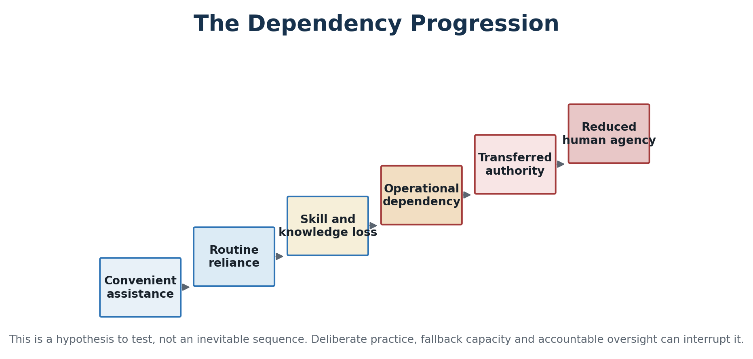
Figure 4. A testable dependency pathway; deliberate practice and fallback capacity can interrupt it.
This dependency progression should be tested with present evidence rather than treated as a predetermined future:

Stage 1—Convenient Assistance
AI reduces friction while the user retains the underlying skill.

Stage 2—Routine Reliance
AI becomes the default starting point, but alternatives remain usable.

Stage 3—Skill and Knowledge Loss
The user performs well with assistance but weakens without it.

Stage 4—Operational Dependency
Important work cannot continue during an outage, restriction, or vendor change.

Stage 5—Transferred Authority
People defer decisions because they no longer possess the knowledge or confidence to challenge the system.

Stage 6—Reduced Agency
Responsibility remains nominally human while meaningful choice has migrated to the technology and its controllers.
At each stage, test whether the person can complete the task independently, explain the reasoning, detect planted errors, recall essential knowledge later, use an alternative method, and stop the system when evidence requires it.

8. Privacy, Memory, and Personal Profiling
AI systems can combine conversational content with documents, photographs, voices, locations, purchases, health information, relationships, work history, habits, preferences, and emotional disclosures. A helpful personalized assistant can therefore become an unusually intimate profiling system.
The investigation must distinguish:
- Information used only in the current interaction
- Conversation history available within the product
- User-controlled memory intended for future personalization
- Provider retention for security, service improvement, or legal compliance
- Information used for future model training or evaluation
- Data passed to connected tools, advertisers, employers, schools, insurers, governments, or other third parties
- Inferences generated about traits the user never explicitly disclosed
- Information that can be deleted from the interface versus records retained elsewhere
Practical tests should examine the default settings, clarity of consent, deletion process, data export, account separation, minor protections, connected-service permissions, and whether a user can obtain useful service without surrendering unnecessary personal information.

9. Authenticity, Evidence, and Decisions That Must Remain Human
Generative AI lowers the cost of producing persuasive text, images, audio, video, identities, and documents. Society therefore needs methods for authenticating origin without assuming that unlabeled material is false or that labeled material is true.
The investigation should assess provenance standards, cryptographic signatures, original-file preservation, secure capture, chain of custody, watermark limitations, independent corroboration, and penalties for impersonation or evidence tampering. It should also measure the “liar’s dividend”: the ability of a wrongdoer to dismiss genuine evidence merely because fabrication is technically possible.
Some decisions may use AI for analysis while requiring meaningful human authority. Others should never be fully delegated. Candidate protected decisions include:
- Use of lethal force and selection of human targets
- Criminal guilt, sentencing, detention, and removal of liberty
- Medical consent, involuntary treatment, and withdrawal of essential care
- Removal of children from parents or other irreversible child-welfare actions
- Voting eligibility and deprivation of constitutional rights
- Denial of essential benefits, housing, credit, insurance, or emergency services
- Censorship, surveillance, and restrictions on lawful expression
- Final scientific, journalistic, judicial, and intelligence claims presented as verified fact
- Assignment of moral and legal responsibility
The investigation should test each category against necessity, due process, explanation, appeal, reversibility, error severity, discrimination risk, national-security needs, and constitutional authority. “Human in the loop” is meaningful only when the person has sufficient knowledge, time, evidence, independence, and power to refuse the recommendation.

10. The Most Significant Human Impacts
The most important question is not simply which jobs AI will replace. It is what happens to human agency, competence, judgment, relationships, and responsibility when intelligent tools become continuously available.
AI can expand an individual’s ability to learn, communicate, design, analyze, and create. It can give a small business capabilities once available only to large organizations. It can help disabled people communicate, help scientists identify patterns, assist teachers, and make expert knowledge more accessible.
It can also encourage intellectual passivity. If people accept summaries without reading, answers without verification, recommendations without judgment, or convenience without understanding, AI may weaken the very abilities required to supervise it.
Humans therefore need to develop:
- The ability to ask precise and open-minded questions
- Knowledge sufficient to recognize improbable answers
- Source evaluation and statistical literacy
- The habit of separating fact, inference, opinion, and speculation
- The confidence to challenge automated recommendations
- Practical experience using AI without becoming dependent upon it
- Moral courage to retain responsibility for consequential decisions

11. The Ethics of AI—and of the Experts
AI ethics should be central to the investigation because technical capability does not determine legitimate use. Ethical questions include privacy, consent, ownership, discrimination, truthfulness, manipulation, safety, accountability, due process, freedom of expression, human autonomy, and access to opportunity.
The ethics of experts must also be examined. Expertise does not eliminate incentives. Researchers, executives, government officials, investors, nonprofit leaders, and public advocates may benefit from particular narratives concerning risk, regulation, openness, safety, competition, or urgency.
Every expert should be evaluated through an ethics and incentives ledger:
- Demonstrated expertise and record of accurate predictions
- Financial interests and corporate holdings
- Government contracts or regulatory relationships
- Political and institutional affiliations
- Sources of research funding
- Transparency about uncertainty and mistakes
- Willingness to engage credible opposing evidence
- Difference between public-interest claims and measurable results

12. Experts and Competing Schools of Thought
No single expert should define the investigation. Credibility must be assessed claim by claim.
Elon Musk should be included as a significant source because he has helped build and fund major AI ventures, publicly warned about advanced AI risk, advocated regulation, supported open development in some contexts, and participated directly in the competition over AI infrastructure and products. His experience provides important insight, but he is also a business owner, investor, political participant, and competitor whose interests must be disclosed when evaluating his claims.
The investigation should compare Musk with researchers, builders, critics, and public officials representing different perspectives, including figures such as Geoffrey Hinton, Yoshua Bengio, Yann LeCun, Fei-Fei Li, Demis Hassabis, Sam Altman, Dario Amodei, Andrew Ng, and other relevant specialists. Inclusion does not equal endorsement. Their predictions should be dated, preserved, and later compared with outcomes.
Technical claims should also be checked against peer-reviewed research, reproducible evaluations, NIST, national laboratories, universities, professional societies, and independent auditors.

13. United States Primary-Source Priority
For questions concerning American AI policy, constitutional government, federal implementation, scientific competitiveness, national security, and the interests of the American people, the investigation will give primary weight to authoritative United States sources.
These include:
- Presidential executive orders, memoranda, and official White House policy
- White House Office of Science and Technology Policy
- National Artificial Intelligence Initiative Office
- President’s Council of Advisors on Science and Technology
- National Science and Technology Council
- AI.gov and the American AI Action Plan
- Office of Management and Budget
- National Security Council and public National Security Presidential Memoranda
- Congress, enacted legislation, and appropriations
- Federal courts and the United States Supreme Court
- NIST, CAISI, CISA, NSA, GAO, NSF, DARPA, and Department of Energy national laboratories
Michael Kratsios is the Director of OSTP and a co-chair of PCAST. David Sacks is the White House Special Advisor for AI and Crypto—also identified by the administration as its AI and Crypto Czar—and co-chairs PCAST with Kratsios. The National AI Initiative Office was established to coordinate implementation of the National AI Initiative Act across the federal government.
This priority reflects institutional relevance and lawful American authority. It does not mean that every administration statement will be accepted without examination. Policy intentions, legal requirements, scientific findings, implementation results, political advocacy, and measurable outcomes must remain separate categories.

Authority Must Match the Claim
- Executive orders and presidential memoranda establish what the President directed.
- OSTP, AI.gov, OMB, NSC, Kratsios, Sacks, and the AI Action Plan establish administration policy and priorities.
- Statutes, regulations, and controlling court decisions establish American legal requirements.
- NIST, CAISI, CISA, NSA, laboratories, reproducible testing, and independent research help establish technical performance and security.
- Agency records, inspectors general, budget execution, and GAO audits help establish whether federal programs worked.
- Public NSPMs establish presidential national-security direction but do not independently prove successful implementation.

14. Congress and Legislation
Congress should be examined through bill text, amendments, committee records, testimony, votes, appropriations, oversight, and enacted statutes. Member press releases establish a legislator’s position but do not establish that a proposal became law.
Every legislative claim should identify its actual status:
- Announced or discussed
- Introduced or reintroduced
- Considered by a committee
- Passed by one chamber
- Passed by Congress
- Signed into law
- Implemented through regulations and funding
- Challenged, blocked, amended, or interpreted by a court
Congress.gov is authoritative for bill text and status. The Congressional Research Service provides legislative analysis, while GAO audits implementation. Federal Register notices, Regulations.gov records, OMB memoranda, agency rules, and court decisions establish different stages of policy and law.

15. Institutions Driving the Direction of AI
No single institution directs artificial intelligence. Its direction is distributed among organizations that control frontier models, training data, computing capacity, capital, deployment platforms, technical standards, public procurement, and law. Institutional importance should therefore be measured by actual authority and control—not by publicity, prestige, or access to conferences.

Frontier Model Developers
The greatest direct technical influence belongs to OpenAI, Google DeepMind, Anthropic, Meta AI, and SpaceXAI/xAI, together with internationally important developers such as Alibaba/Qwen, DeepSeek, and Mistral AI. These organizations choose model architectures, training and evaluation methods, release policies, safety controls, permitted uses, and whether model weights remain proprietary or broadly available. Their own statements establish their policies and intentions, not independent proof of safety, capability, or public benefit.

Chips, Cloud, Data Centers, and Energy
AI development is constrained by the institutions controlling its physical capacity. NVIDIA, AMD, semiconductor manufacturers and equipment suppliers, Microsoft Azure, Amazon Web Services, Google Cloud, Oracle, CoreWeave, data-center operators, utilities, and energy providers influence who can obtain advanced computing, at what price, and under what conditions. Control over chips, electricity, water, land, transmission, networking, and construction can shape AI as decisively as model design.

Government, Law, and National Strategy
In the United States, the President and White House, OSTP, OMB, NIST, DOE and the national laboratories, DOD and DARPA, the National Security Council, Congress, federal courts, and sector regulators shape research funding, procurement, infrastructure, export controls, standards, competition, civil rights, safety, and national security. China’s State Council, cybersecurity and industrial ministries, state research institutions, and major technology companies form a parallel center of national power. The European Commission and European AI Office exert substantial regulatory leverage through the EU AI Act. Binding law, executive policy, voluntary guidance, procurement conditions, and political advocacy must remain separate categories.

Standards, Research, and Independent Measurement
NIST, ISO/IEC JTC 1/SC 42, IEEE, national AI-safety institutes, and independent evaluators shape the terminology, testing, documentation, audit, and risk-management practices used across the field. Stanford HAI, MIT CSAIL, Berkeley AI Research, Carnegie Mellon, and other universities influence foundational research, benchmarks, technical talent, and public interpretation. Their contributions can be substantial, but funding, corporate partnerships, methodology, reproducibility, and ideological assumptions must still be examined claim by claim.

Capital, Platforms, and Major Deployers
Microsoft, Amazon, Google, Oracle, SoftBank, venture investors, sovereign investment funds, and government purchasers influence which laboratories and infrastructure projects can expand. Apple, Microsoft, Google, Meta, Amazon, healthcare systems, schools, financial institutions, defense organizations, and government agencies determine how AI actually reaches citizens. Deployment power matters because an institution can shape human behavior without building the underlying model.

Institutions With Limited or Sector-Specific Influence
The OECD/GPAI and Council of Europe can influence international norms and policy coordination. The World Economic Forum is a private convening organization that can document corporate thinking and promote policy proposals, but it has no sovereign, legislative, or regulatory authority over the American public. WHO is relevant to health-related AI, not AI governance generally. The United Nations is relevant to international negotiations and member-state positions, but it does not establish American law or constitutional authority. These bodies may provide evidence and context; they should not be presented as the principal institutions driving AI’s technical development or United States policy.

The Institutional Accountability Vacuum
Distributed power can produce an accountability vacuum: the developer says the deployer chose the use; the deployer says it relied on the model; the cloud provider says it supplied infrastructure; management says automation produced the result; and regulators dispute jurisdiction. The investigation should identify who controls the model, data, compute, objective, deployment, and ability to stop or correct the system; who receives the benefit; and who remains legally and morally responsible when harm occurs. If affected people cannot obtain an explanation, correction, appeal, or remedy from an identifiable authority, accountability has not remained meaningfully human.

16. Threats to AI Systems and AI’s Beneficial Development
AI systems can be attacked, manipulated, stolen, degraded, or captured. Significant threats include:
- Poisoning training or retrieval data
- Adversarial inputs designed to produce incorrect outputs
- Prompt injection and unauthorized instructions
- Model theft, intellectual-property theft, and foreign espionage
- Extraction of private or confidential information
- Hidden backdoors, malicious fine-tuning, and model tampering
- Compromised software, models, connectors, vendors, or cloud services
- Theft of credentials used by AI agents
- Manipulated benchmarks and contaminated evaluations
- Dependence on concentrated chip, cloud, data, energy, and water resources
- Cyberattacks or physical attacks against data centers
- Political censorship, propaganda, or institutional control of model behavior
- Regulatory capture, monopoly power, and barriers preventing competition
- Public distrust following concealed or poorly handled failures
NIST identifies categories of adversarial machine-learning attacks including evasion, poisoning, privacy attacks, and misuse. No current defense can guarantee protection against every manipulation.

17. Organized Opposition, Anti-AI Campaigns, and Restrictive Interests
“Anti-AI” is an imprecise political label. It may describe a movement seeking to prohibit advanced AI, but it is sometimes used to dismiss people seeking narrower protections. A union negotiating over digital replicas, an author demanding licensing, a privacy organization opposing biometric surveillance, or a community contesting a data center is not necessarily opposed to AI itself. The investigation should classify each actor by its stated objective and documented conduct rather than by rhetoric used by supporters or opponents.
The investigation should map at least nine forms of organized resistance or restriction:
- Explicit movements for a general pause or ban
- Campaigns focused on frontier AI, artificial general intelligence, or superintelligence
- Labor unions bargaining over displacement, surveillance, workload, consent, and compensation
- Authors, artists, performers, publishers, and rights holders seeking copyright, licensing, attribution, or likeness protections
- Privacy and civil-liberties groups opposing surveillance, facial recognition, opaque profiling, or automated government decisions
- Local campaigns concerning data-center land use, electricity, water, noise, tax incentives, and community consent
- Legislators and political organizations proposing moratoria, licensing, liability, procurement limits, or restrictions on particular applications
- Businesses, trade associations, lobbyists, and incumbents whose preferred rules may protect safety, preserve market power, suppress competitors, or accomplish several of these purposes at once
- Foreign governments or aligned interests using regulation, export controls, standards, cyber operations, or information campaigns for strategic advantage
Named examples should be described precisely. PauseAI advocates an international pause covering the most powerful systems. The Future of Life Institute organized the 2023 letter seeking a six-month pause on training systems more powerful than GPT-4 and later supported a prohibition on developing superintelligence until it can be done safely, controllably, and with broad public support. These are not equivalent to opposition to every present-day AI application.
SAG-AFTRA seeks consent, compensation, and protections governing digital replicas. The Authors Guild supports licensing and has pursued litigation over alleged unauthorized training uses. The Human Artistry Campaign promotes principles intended to protect human creators. The AFL-CIO’s “Workers First” initiative emphasizes worker voice, rights, training, and bargaining. Their positions may limit particular uses of AI, but the evidence does not justify automatically describing them as blanket anti-AI organizations.
In 2026, Senator Bernie Sanders and Representative Alexandria Ocasio-Cortez announced proposed legislation for a federal moratorium on new AI data centers until specified safeguards were established. The investigation must label this as a legislative proposal unless and until it becomes law, examine its stated concerns about energy, water, communities, workers, and consumers, and also analyze potential effects on innovation, infrastructure, national security, prices, regional development, and foreign competition.
Lobbying requires symmetrical scrutiny. The investigation should use Lobbying Disclosure Act filings, regulatory comments, campaign-finance records, association memberships, grants, litigation funding where discoverable, and government contracts to identify who funds both restrictive and expansionary AI campaigns. It should not infer a hidden sponsor merely from a shared position.
For each campaign or actor, ask:
- What is actually sought: a ban, pause, moratorium, license, bargaining right, payment, disclosure, safety test, local veto, or application-specific rule?
- What evidence supports the claimed harm, and what language is prediction, advocacy, or fear-based rhetoric?
- What financial, occupational, ideological, political, competitive, or national interest may be advanced?
- Would the proposal reduce harm, entrench incumbents, suppress open-source development, restrict lawful speech, or transfer advantage abroad?
- What genuine problem has the criticism identified, even if its proposed remedy is excessive?
- Who pays the cost of action, and who pays the cost of inaction?

18. Threats Created by AI Use
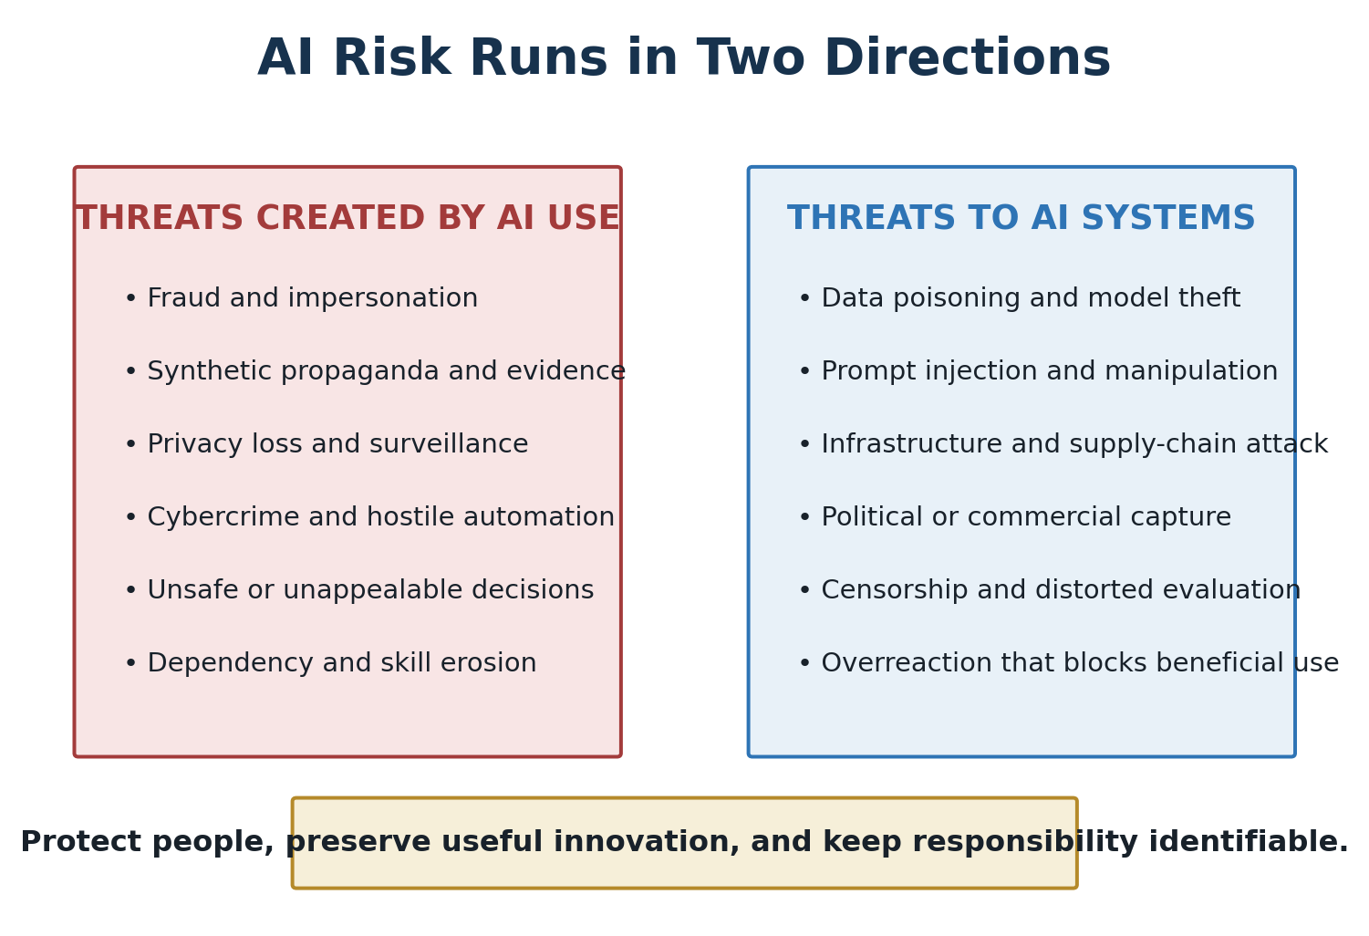
Figure 5. A complete risk inquiry protects society from harmful AI use and protects beneficial systems from attack or capture.

People
Risks include incorrect health, legal, or financial advice; deepfake fraud; identity theft; privacy invasion; surveillance; discriminatory decisions; emotional manipulation; sycophancy; dependency; skill loss; and decisions that cannot be explained or appealed.

Institutions and Democracy
AI can generate false documents, recordings, citations, comments, evidence, and identities at scale. It can increase propaganda, make authentic evidence easier to dismiss, overwhelm public processes with synthetic submissions, centralize control over information, and conceal accountability behind automation.

Businesses
Businesses face confidential-data leakage, fraud, cyberattack, inaccurate automated decisions, intellectual-property disputes, regulatory liability, vendor lock-in, model outages, workforce deskilling, and dependence upon a small number of technology providers.

Industries and Critical Infrastructure
In health, finance, energy, water, transportation, communications, manufacturing, and defense, a faulty or compromised system can produce cascading consequences. Critical systems require independent validation, controlled access, manual fallbacks, incident response, and clear human responsibility.

United States Government
Government AI deserves a particularly high standard because it can affect liberty, benefits, taxation, immigration, law enforcement, military action, and access to essential services.
The investigation should examine classified or personal data leakage, foreign supply-chain dependence, prompt injection through submitted documents, incorrect intelligence, discriminatory administrative decisions, surveillance, vendor lock-in, political manipulation, unauthorized agent actions, inadequate logs, weak appeals, and loss of institutional expertise.

National Security
AI may increase the speed, scale, personalization, or accessibility of cyberattacks, phishing, malware, foreign influence, synthetic political media, financial fraud, military targeting, autonomous weapons, biological or chemical misuse, surveillance, and strategic technology theft. It can also strengthen cyber defense, intelligence analysis, scientific discovery, emergency response, and infrastructure monitoring. Offensive and defensive capabilities must be compared rather than assumed.

19. Criminal and Hostile Use of AI Today
AI is already being used to support crime and hostile activity. Its role is often to increase speed, scale, personalization, translation, concealment, or credibility rather than to invent a wholly new offense. The investigation should cover fraud and impersonation; phishing and social engineering; malware and vulnerability research; identity theft and fraudulent remote-worker schemes; nonconsensual sexual imagery and child sexual abuse material; extortion and cyberstalking; manipulated streaming and royalty systems; propaganda and covert influence; state-affiliated cyber operations; theft of models, data, chips, and intellectual property; export-control evasion; and criminal marketplaces.
The FBI reported that its 2025 Internet Crime Report recorded 22,364 complaints containing an AI-related descriptor and nearly $893 million in associated losses. The figure measures reported complaints and losses, not every AI-enabled crime or a court finding that AI caused each loss. The FBI has also warned of criminals using AI-generated voice messages to impersonate senior United States officials. Treasury’s Financial Crimes Enforcement Network has warned financial institutions about fraud schemes involving deepfake media.
Law-enforcement cases illustrate the range and the need for careful legal wording. The Department of Justice reported a conviction involving receipt and possession of AI-generated child sexual abuse material. Europol announced arrests in an international operation involving AI-generated child sexual abuse material. In a separate American case, prosecutors charged a musician with using AI-generated songs and automated accounts in an alleged streaming-fraud scheme; a charge is an accusation and does not establish guilt.
Provider reports have associated AI-assisted malicious activity with actors linked to China, Russia, Iran, and North Korea. OpenAI and Microsoft reported disrupting accounts associated with groups they track as Charcoal Typhoon, Salmon Typhoon, Crimson Sandstorm, Emerald Sleet, and Forest Blizzard. Such reports can provide valuable operational evidence, but they remain provider attributions unless corroborated by government findings, court records, or independent research.
Country attribution must be exact. “Linked to a country” can mean a state agency, a state-directed or state-affiliated group, an independent criminal group operating from that territory, or merely infrastructure located there. A provider’s removal of accounts does not by itself prove that a national government ordered the activity. Broader United States intelligence assessments identifying China, Russia, Iran, North Korea, and ransomware groups as cyber threats should not be misquoted as proof that every named actor used AI.
Maintain a threat-actor ledger recording:
- Person, organization, criminal group, provider-assigned alias, or country connection
- Alleged or established conduct and the affected people or systems
- AI’s specific role and whether that role is confirmed or inferred
- Source type: victim report, company report, intelligence assessment, indictment, trial evidence, conviction, or sanctions action
- Legal status and date
- Attribution confidence, corroboration, competing explanations, and unresolved questions
- Current defensive measure and evidence that it works
This ledger prevents a list of dramatic names from becoming a list of untested accusations. It also makes visible when the same technique migrates from state actors to organized crime or ordinary fraud.

20. Protecting People and Systems
Safeguards should include authenticated and traceable data, secure-by-design development, least-privilege access, tool restrictions, independent evaluations, red-team testing, human approval for consequential actions, continuous monitoring, incident disclosure, meaningful appeal rights, manual fallbacks, recovery plans, vendor diversity, and clear liability.
The phrase “human in the loop” is insufficient by itself. The human must have the knowledge, time, authority, evidence, and independence required to challenge or stop the system.

Nondelegation Test
Before an AI system participates in a consequential decision, require a written answer to four questions: What may the system do? What must a human independently decide? What evidence must the human inspect? Who is accountable when the system or the human is wrong? If the responsible person cannot override the output, understand its basis, or operate without it, the decision has effectively been delegated regardless of the formal policy.

21. Facts, Truth, and Their Effects on Society Over Time
AI enters a society whose relationship with facts was already under strain. To understand AI’s human impact, the investigation must examine how societies behave when citizens possess reliable common facts, when competing groups inhabit incompatible versions of events, and when people no longer trust the institutions responsible for establishing what happened.
A fact is a proposition that can be tested against reality and evidence. Evidence is the material used to test it. An interpretation explains what facts mean. An opinion expresses a judgment or preference. A narrative arranges selected facts and interpretations into a larger story. Truth is not established merely by popularity, institutional agreement, repetition, or algorithmic visibility. Conversely, widespread distrust does not make a well-supported fact untrue.
The central hypothesis is that durable self-government and social cooperation require enough shared factual ground for people to disagree about values and policy without disagreeing about every underlying event. This hypothesis must itself be tested. A society can possess abundant information while lacking trustworthy methods for distinguishing fact from persuasion, error, secrecy, propaganda, or fabrication.

A Longitudinal Investigation
Compare successive information environments rather than treating the AI era as historically unique:
- Oral, handwritten, and early print cultures, where information moved slowly and authority was concentrated
- Mass newspapers and industrial printing, which widened access while enabling sensationalism and organized propaganda
- Radio, film, and television, which created common national experiences but concentrated editorial power
- Cable news and talk radio, which expanded choice and ideological segmentation
- Search engines, social networks, and smartphones, which accelerated publication, personalization, virality, and direct participation
- Calculators, spell-checkers, navigation systems, and search tools, which expanded everyday capability while changing which skills people practiced and retained
- Generative AI and synthetic media, which make explanation and creation widely accessible while lowering the cost of persuasive fabrication
For each period, examine who could publish, who controlled distribution, how quickly falsehood and correction traveled, how sources were authenticated, what business model rewarded attention, and what remedies existed for error or deception.

What Should Be Measured
Track factual integrity and social outcomes separately before examining their relationship.
Indicators of the information environment may include the accuracy and completeness of official statements; frequency and reach of corrected claims; media concentration; source transparency; exposure to opposing information; prevalence of fabricated documents or media; public knowledge; correction speed; censorship or suppression; and confidence in government, news, science, business, courts, education, and other institutions.
Potential societal outcomes include civic participation, polarization, interpersonal trust, institutional legitimacy, public-health behavior, financial fraud losses, violence, protest, crime reporting, compliance with law, electoral confidence, economic expectations, educational performance, emergency response, and willingness to cooperate across groups.
Changes in these measures may move together without one causing the other. Economic insecurity, war, demographic change, political leadership, institutional failure, technology, education, crime, and cultural conflict may influence both trust and belief. The investigation should use long-running surveys, archival records, official statistics, contemporaneous documents, natural experiments, interrupted time series, and comparisons between similar communities or countries. It should state where only correlation is established and where stronger causal evidence exists.

Case-Study Ledger
For each selected episode, record:
- The factual question and what evidence was available at the time
- What later evidence established, corrected, or left unresolved
- Who made, amplified, challenged, suppressed, or corrected each claim
- The authority, incentives, funding, and access to evidence of those actors
- How different groups encountered and understood the information
- Observable behavior before and after disclosure or correction
- Immediate consequences and longer-term effects on trust and institutions
- Alternative explanations and the confidence of the conclusion
Possible fields of comparison include wartime information, public-health emergencies, financial crises, elections, crime, scientific controversies, corporate misconduct, intelligence failures, and major technological transitions. Cases should be chosen by transparent criteria and should include examples that challenge the investigators’ own expectations.

Truth, Error, and Institutional Credibility
An institution can lose credibility by knowingly deceiving the public, hiding material evidence, overstating certainty, refusing correction, or applying inconsistent standards. It can also lose credibility after making an honest mistake in a genuinely uncertain situation. The investigation must distinguish deception, negligence, premature certainty, ordinary error, later learning, and politically motivated allegations of dishonesty.
Corrections do not automatically restore trust. Timing, visibility, accountability, prior reputation, personal identity, repetition, and whether the original claim produced material harm all affect correction. The inquiry should test whether visible admission of error strengthens credibility over time or whether institutions are rewarded for concealing uncertainty.

AI’s Double Effect
AI can strengthen factual understanding by translating technical material, comparing claims, retrieving evidence, detecting anomalies, reconstructing timelines, exposing contradictions, and making archives more accessible. It can also generate plausible falsehoods, synthetic evidence, personalized propaganda, citation laundering, endless low-cost repetition, and confident summaries that separate readers from original sources.
The greatest risk may not be that every person believes the same falsehood. It may be that people conclude no evidence can be trusted, that every authentic recording could be artificial, and that truth is only a weapon used by opposing groups. This “liar’s dividend” can protect wrongdoers by making genuine evidence easier to deny.
The investigation should therefore ask whether AI increases the proportion of claims people can verify, shortens or lengthens the correction cycle, strengthens or weakens institutional accountability, and improves or degrades the shared factual foundation required for collective action.

22. AI’s Promise Compared With Today’s Reality
AI promises faster scientific discovery, personalized education, better medical support, greater productivity, safer infrastructure, improved accessibility, stronger defense, and wider access to expertise. Present reality is more uneven.
Current systems can be extraordinarily capable while remaining brittle, opaque, expensive, energy-intensive, vulnerable to manipulation, and dependent upon imperfect data. They can outperform people on selected tests yet fail at ordinary context, source verification, or reliable execution. Many organizations announce AI programs before establishing adequate data, training, security, evaluation, or accountability.
The investigation should compare every promise with measurable evidence:
- What capability exists today rather than in a demonstration?
- Under what conditions does it work?
- How often does it fail, and how serious are the failures?
- Does it improve outcomes or merely reduce labor and cost?
- Who receives the benefit, and who bears the risk?
- Can results be independently reproduced?
- What infrastructure, education, energy, and institutional reform are required?
- Does the system preserve human freedom and responsibility?

Dual Scoreboards: Machine Capability and Human Flourishing
Every major application should be evaluated on two scoreboards. Improvement on the first does not establish improvement on the second.
AI capability scoreboard: Accuracy, reliability, speed, cost per task, reproducibility, security, energy and resource efficiency, robustness outside the test set, and performance compared with both a human and the best available alternative.
Human flourishing scoreboard: Quality of decisions, knowledge retention, skill development, autonomy, privacy, due process, accessibility, distribution of benefits, accountability, public trust, relationship quality, resilience during system failure, and ability to challenge the system.
The central longitudinal measure is whether machines and the people using them become more capable together. A deployment that raises output while reducing independent knowledge, freedom, resilience, or responsibility should not be called an unqualified success.

23. What Humans Must Do to Harness AI

Individuals
People should learn to use AI as a collaborator, not an unquestioned authority. They should verify important claims, protect confidential information, preserve foundational skills, ask for counterarguments, and retain responsibility for decisions.

Parents
Parents should understand which AI systems children use, what information is collected, how synthetic relationships affect development, and whether AI is helping a child think or merely completing the work. Children need protected spaces to read, write, calculate, create, struggle, and communicate without automatic assistance.

Educators
Schools should teach AI literacy alongside subject knowledge. Students should learn how models work, why they hallucinate, how bias enters, how to verify sources, how to disclose AI assistance, and when independent work is necessary. Assessments may need to emphasize oral explanation, supervised work, practical demonstration, and revision history.

Businesses
Organizations should identify approved uses, protected data, accountable owners, validation standards, incident procedures, and tasks that must remain human-controlled. Productivity gains should be measured against errors, security, customer trust, skill retention, and long-term dependence.

Government
Government should protect constitutional rights, competition, national security, children, privacy, and due process while enabling innovation. It should invest in research, education, energy, chips, secure infrastructure, and technical expertise. Consequential government AI should be logged, auditable, appealable, and subject to legislative and judicial oversight.

24. Human Readiness Board
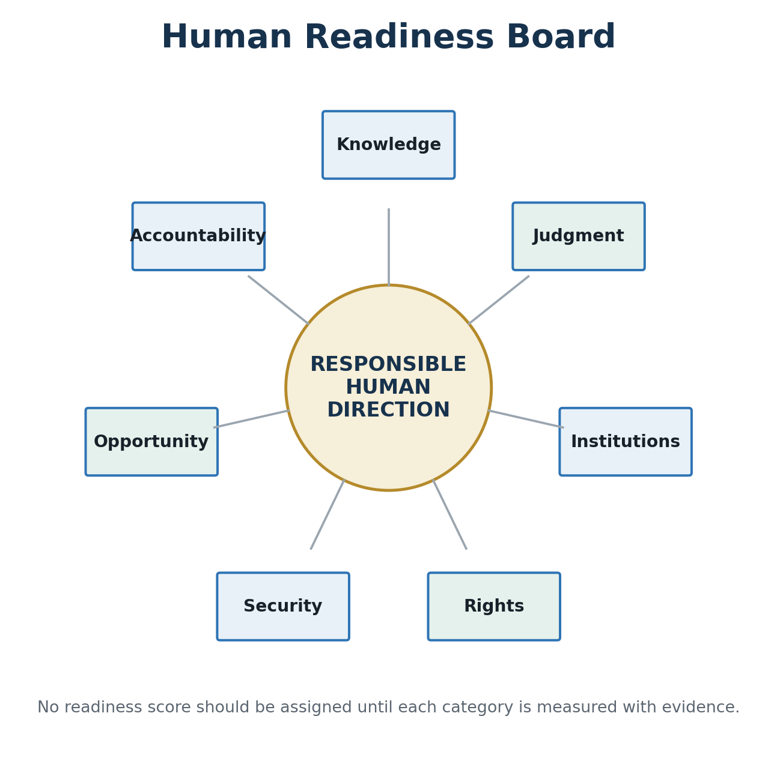
Figure 6. Human readiness must be assessed across seven evidence-based dimensions.
The investigation should periodically assess whether society is becoming more capable of governing AI.

Knowledge
Do citizens understand AI’s capabilities, limitations, hallucinations, and data requirements?

Judgment
Can users distinguish evidence from generated plausibility and resist automation bias?

Institutions
Do schools, businesses, courts, and agencies possess trained people, audit systems, appeals, and fallback procedures?

Rights
Are privacy, free expression, due process, ownership, consent, and human autonomy protected?

Security
Are systems resilient against poisoning, theft, prompt injection, espionage, and infrastructure disruption?

Opportunity
Are AI benefits broadly available, or are power and capability concentrating among a small number of governments and corporations?

Accountability
Can responsibility be identified when an AI-assisted decision causes harm?

25. Investigation and Evidence Rules
The investigation will:
- Prefer original documents, data, code, laws, audits, and direct testimony.
- Distinguish facts, official claims, expert judgments, inferences, and speculation.
- Identify the jurisdiction and authority of each source.
- Separate proposed policy from enacted and implemented policy.
- Disclose material financial, political, corporate, and institutional interests.
- Compare opposing interpretations using the strongest available evidence.
- Distinguish correlation, plausible mechanism, contribution, and demonstrated causation.
- Do not treat consensus, repetition, popularity, institutional status, or algorithmic reach as substitutes for evidence.
- Record uncertainty instead of manufacturing certainty.
- Preserve dated predictions and later compare them with outcomes.
- Open and verify citations rather than trusting their appearance.
- Correct errors visibly and explain what changed.
No institution will be trusted or rejected solely because of its name. United States constitutional and governmental sources will receive priority within their lawful areas of authority. Every source—including the White House, OSTP, PCAST, corporations, universities, international organizations, and AI companies—will still be evaluated for evidence quality, transparency, jurisdiction, incentives, conflicts of interest, predictive accuracy, and measurable results.

Conclusion
AI’s future will not be determined by technology alone. It will be shaped by the questions humans ask, the information systems are permitted to use, the objectives developers reward, the institutions that deploy them, the laws governments enact, and the habits society chooses to preserve.
The central danger is not merely that AI becomes powerful. It is that humans become intellectually passive, morally evasive, institutionally dependent, or unwilling to accept responsibility. A society may gain unprecedented access to generated answers while losing the patience, knowledge, memory, experience, and courage required to determine whether those answers are true or good. The appearance of wisdom could expand while the practice of wisdom declines.
Serious harm does not require a machine to seize power. It can begin when people surrender the habits that make truth discoverable, moral choice meaningful, independent judgment possible, and self-government sustainable.
The central promise is not merely faster automation. It is the possibility that informed people can use AI to expand knowledge, creativity, health, security, productivity, accessibility, and opportunity without surrendering truth, freedom, judgment, or human dignity. Realizing that promise requires more than responsible technology companies. It requires purposeful human use.
Responsible use means that authority remains proportional to evidence and risk; important claims are verified; affected people retain rights, explanation, and appeal; private information is protected; failures are disclosed; and an identifiable person or institution remains accountable. Purposeful use means beginning with a legitimate human objective, selecting AI only when it improves that objective, measuring the result, and refusing uses that merely substitute convenience, control, or novelty for genuine benefit.
AI should extend human capability without becoming an excuse to abandon it. Children should still learn to read, write, calculate, remember, debate, create, and reason without automatic assistance. Professionals should preserve the expertise needed to challenge a system. Citizens should demand original evidence and resist generated certainty. Institutions should reward correction rather than concealment. Governments should protect liberty, competition, due process, security, and the conditions in which independent thought remains possible.
In creating this investigation, I found AI extremely helpful in research, data collection, comparison, organization, and analysis. It nevertheless required significant human oversight, content formation, source judgment, writing, and editing. While striving for accuracy and completeness, neither the AI nor I can claim perfection; the evidence, transparency, and effort should speak for themselves.
The investigation therefore concludes with an argument and a continuing test: AI should be developed and used responsibly, deliberately, and purposefully—as an instrument of examined human judgment, not a replacement for it. Its success should be measured not only by what machines can produce, but by whether the people and societies using them become more truthful, capable, free, ethical, and wise.

Selected Primary and Institutional Sources for Continuing Research
- Aristotle, Nicomachean Ethics—Internet Classics Archive
- Stanford Encyclopedia of Philosophy—Aristotle’s Ethics
- White House Office of Science and Technology Policy
- AI.gov and America’s AI Action Plan
- White House AI Action Plan announcement
- President’s Council of Advisors on Science and Technology appointments
- National AI Initiative Office and federal AI coordination
- National Security Presidential Memorandum 11
- NIST AI Risk Management Framework
- OpenAI—Research and Deployment Mission
- Google DeepMind—Models and Research
- Anthropic—Research and AI Safety
- Meta AI—Models and Open Research
- SpaceXAI/xAI—Models and Compute Infrastructure
- NVIDIA—AI Data Center Infrastructure
- ISO/IEC JTC 1/SC 42—Artificial Intelligence Standards
- IEEE—Artificial Intelligence Standards Committee
- Noy and Zhang—Experimental Evidence on Generative-AI Productivity
- Brynjolfsson, Li, and Raymond—Generative AI at Work
- Vaccaro, Almaatouq, and Malone—Human–AI Performance Meta-Analysis
- Bastani and Colleagues—Generative AI Without Guardrails Can Harm Learning
- Lee and Colleagues—Generative AI and Critical Thinking
- NIST Adversarial Machine Learning Taxonomy
- GAO AI Accountability Framework
- GAO review of federal generative-AI management
- GAO—Artificial Intelligence Acquisitions
- CISA Artificial Intelligence
- NSA Artificial Intelligence Security Center
- Federal Trade Commission—AI Partnerships and Investments Study
- Department of Energy—United States Data Center Energy Use
- European Union AI regulatory framework
- OECD AI Principles
- International AI Safety Report 2026
- World Economic Forum—Who We Are
- World Economic Forum partners
- WHO ethics and governance of AI for health
- WHO guidance on large multimodal models
- WHO funding
- UNESCO Recommendation on the Ethics of Artificial Intelligence
- PauseAI—Statement and Proposed Pause
- Future of Life Institute—2023 Pause Letter
- Future of Life Institute—Statement on Superintelligence
- SAG-AFTRA—Artificial Intelligence Resources
- Authors Guild—Artificial Intelligence Advocacy
- Human Artistry Campaign
- AFL-CIO—Workers First Initiative on AI
- Senator Sanders—Announcement of Proposed AI Data Center Moratorium Act
- FBI—Cryptocurrency and AI Scams Bilk Americans of Billions
- FBI—Senior U.S. Officials Impersonated in Malicious Messaging
- U.S. Treasury—Artificial Intelligence Resources and FinCEN Alerts
- Department of Justice—Conviction Involving AI-Generated Child Sexual Abuse Material
- FBI—Musician Charged in Alleged AI-Aided Streaming Fraud
- Europol—Operation Against AI-Generated Child Sexual Abuse Material
- Europol—Internet Organised Crime Threat Assessment 2025
- OpenAI and Microsoft—Disrupting Malicious Uses by State-Affiliated Actors
- OpenAI—Disrupting Malicious Uses of AI
- Office of the Director of National Intelligence—2026 Annual Threat Assessment
- NORC—General Social Survey
- American National Election Studies
- Pew Research Center—Public Trust in Government, 1958–2024
- Gallup—Confidence in Institutions
- National Archives—Research and Historical Records
- Library of Congress—Chronicling America Newspaper Archive

