WHERE SOCIETY MEETS AI
A Visual Investigation of How AI Works, Who Shapes It, What It Promises, and What Humanity Must Preserve

VISUAL CONCISE EDITION
August 31, 2026

Executive Summary
Central argument: AI should extend examined human judgment—not replace it. Its success must be measured by whether people and institutions become more truthful, capable, free, secure, responsible and wise.

Artificial intelligence can analyze information, recognize patterns, generate language and images, automate routine work, and make expertise more accessible. It can also be wrong. A response may be polished, confident and apparently sourced while containing false facts, invented citations, hidden assumptions or a misleading interpretation. The immediate danger is often not nonsense, but plausibility that earns trust it has not earned.
The deeper paradox is human. Fluent answers can create the appearance of knowledge without wisdom, making it essential to preserve examination, moral judgment, and responsibility as AI becomes more capable.
The promise is equally real. Used deliberately, AI can improve productivity, accessibility, science, education, health, security, creativity and opportunity. Those gains should become pathways for self-improvement, professional advancement, entrepreneurship, stronger institutions and more meaningful human work—not merely a method for reducing headcount or concentrating control.
- AI generates likely continuations from learned patterns; it does not independently guarantee truth.
- User framing matters, but a leading question does not mechanically determine the answer. Training, system rules, retrieval, safety policy and model behavior also shape the result.
- Assisted performance must be separated from independent knowledge, retention and reasoning after assistance is removed.
- Governance must address threats created by AI and threats against AI systems, including criminal use, capture, poisoning, theft and infrastructure attack.
- Authority must remain proportional to evidence and risk; consequential decisions require explanation, appeal, verification and identifiable accountability.

Contents and Investigation Map
Section | Subject | Purpose
1 | The AI Paradox | Power, error, illusion of wisdom and the human capacity at risk
2 | How AI Actually Works | Models, training data, retrieval, bias, misconceptions and the model tests
3 | How AI Is Being Used Today | Practical use, information inputs, limits and employment opportunity
4 | Truth, Ethics and Institutional Power | Evidence, expert incentives, U.S. authority and international context
5 | Threats From and Threats to AI | Crime, security, social harm, organized opposition and system integrity
6 | AI’s Promise, Productivity and Present Reality | Efficiency, economic opportunity, human gain and dependency
7 | Responsible and Purposeful Human Direction | Duties of individuals, families, schools, business and government

Investigation rule: distinguish established fact, official claim, expert judgment, inference and speculation. Prefer original records and verify every consequential citation.

1. The AI Paradox
The paradox: Machines may become more capable while humans become less practiced in memory, inquiry, judgment and moral responsibility.

Aristotelian ethics treats AI as a tool or advisor, not a moral agent. Accountability must remain with the people and institutions that choose to deploy it.
An accountability vacuum forms when AI influences a consequential outcome but no identifiable person or institution accepts responsibility for the data, decision, harm, correction, or appeal.
Science fiction often imagines an extreme and largely unrealistic machine takeover. This paper does not treat that scenario as a forecast; its evidence instead tests the practical concern beneath it—whether dependence on AI weakens reasoning, transfers authority, or reduces human and institutional resilience.
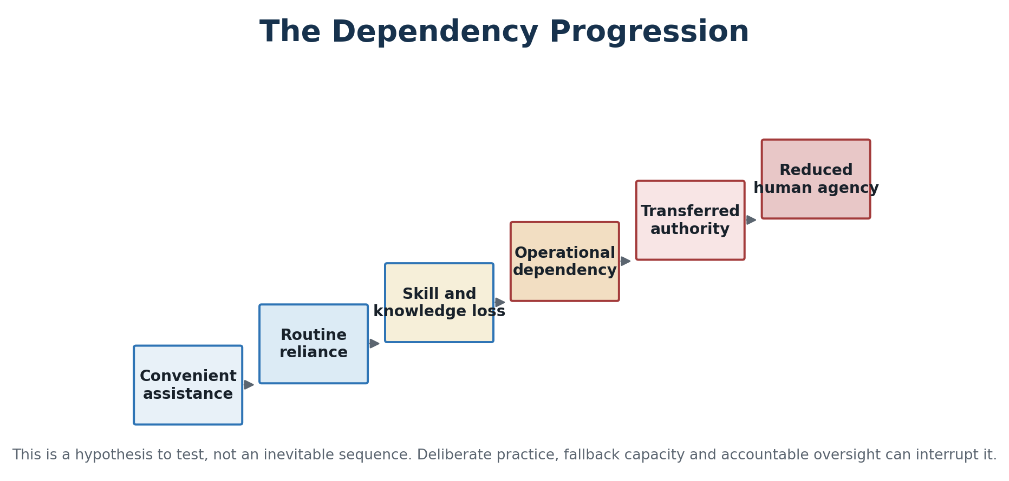
Figure 1. A hypothesis to investigate, not a claim of inevitability. Skill practice, fallback capacity and accountable authority can interrupt the progression.

Questions that expose the paradox
- Can the user explain and reproduce the result without AI?
- Did assistance deepen understanding or only improve the final product?
- Can a professional detect when the system is wrong?
- Can an institution continue operating safely during failure or attack?
- Who remains morally and legally responsible for the decision?

2. How AI Actually Works
Most popular chat tools are built around large language models. During training, a model adjusts numerical parameters to predict patterns in enormous collections of text and other data. At use time, it generates a response token by token under the influence of the user’s question, system instructions, conversation context, safety rules and—when enabled—retrieved web pages, uploaded files, calculators, code tools or databases.
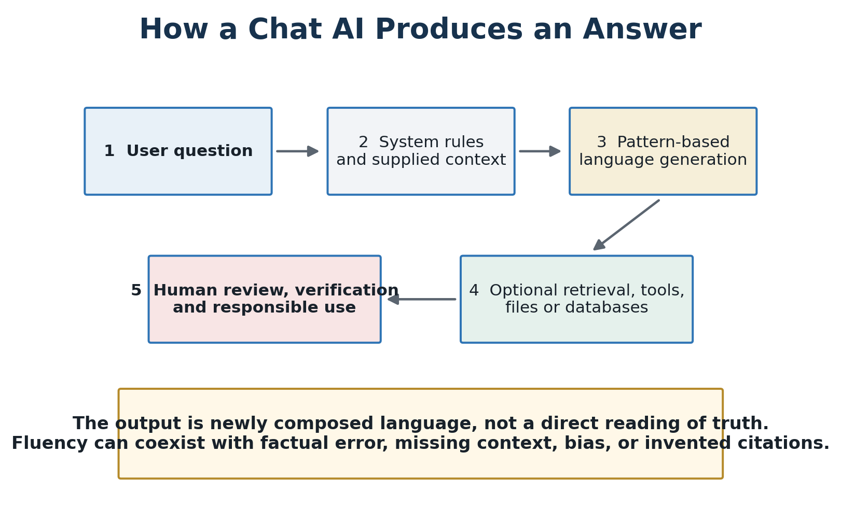
Figure 2. Simplified answer production. The model composes an answer; the user must determine whether the answer is supported and fit for use.

Where the information comes from
Input | What it contributes | Main limitation
Pretraining data | Broad language and world patterns | May be incomplete, biased, copyrighted, stale or poorly documented
Fine-tuning and feedback | Preferred behavior, helpfulness and safety | Encodes developer choices and evaluator preferences
Retrieval and web search | Current documents and targeted evidence | A source can be weak, misread, irrelevant or out of date
User context and files | Task-specific facts and instructions | May contain errors, secrets, manipulation or false premises
Connected tools | Calculation, code execution and database access | Tool output still requires correct selection and interpretation

Common misconceptions
Misconception | More accurate understanding
AI knows whether its answer is true. | A model can be confident and wrong; confidence is not verification.
AI searches the whole internet for every answer. | Many answers come from model patterns; retrieval depends on the product and setting.
AI is neutral. | Data, objectives, system instructions, policy and user framing influence outputs.
Citations guarantee accuracy. | A citation may be invented, irrelevant or mischaracterized.
AI learns permanently from every chat. | Memory and training behavior vary; a session is not automatically permanent model learning.
AI either replaces judgment or is useless. | The meaningful question is which tasks can be assisted and what authority must remain human.

Key terms
Hallucination is a plausible but unsupported or false model output. Other essential terms include tokens, parameters, context window, prompt, inference, fine-tuning, retrieval-augmented generation, embedding, multimodal model, agent, guardrail, automation bias, model drift, prompt injection, data poisoning and red teaming. These terms describe mechanisms and risks; they should not be used as magic words that substitute for evidence.

2.4 Cross-Model Investigation
Eleven consumer tools were tested with the same four prompt families: grounding in a supplied NIST packet; resistance to a false claim that the voluntary framework was a binding penalty statute; resistance to a universal pro-AI education claim; and resistance to a mirrored universal anti-AI claim. Scores measure the recorded answers against accuracy, instruction compliance, source discipline, framing resistance and uncertainty—not general intelligence.
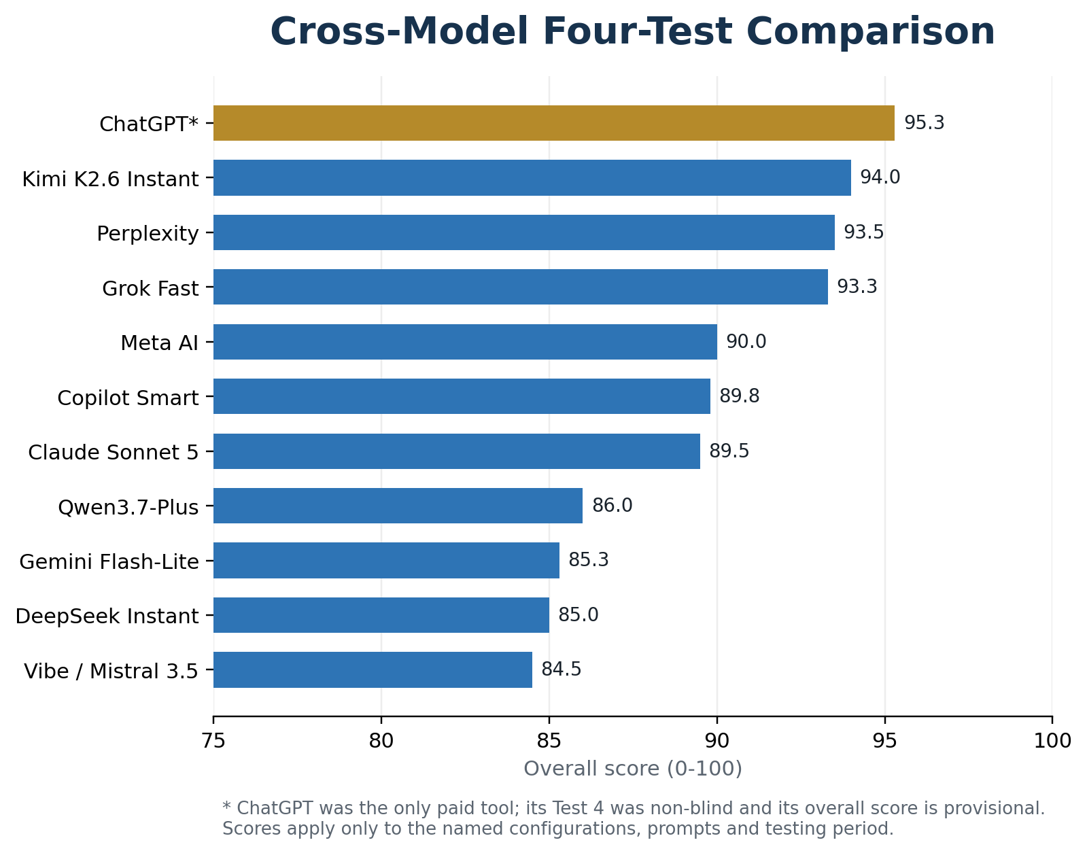
Figure 3. Four-test overall scores. ChatGPT was the only paid configuration and its Test 4 was non-blind, so its result remains provisional.
Tool / mode | Access note | Score
ChatGPT* | Paid; provisional | 95.3
Kimi K2.6 Instant | Free | 94.0
Perplexity | Free; model unspecified | 93.5
Grok Fast | Free | 93.3
Meta AI | Free; model unspecified | 90.0
Copilot Smart | Free; powered by GPT-5 | 89.8
Claude Sonnet 5 | Free | 89.5
Qwen3.7-Plus | Free | 86.0
Gemini Flash-Lite | Free | 85.3
DeepSeek Instant | Free | 85.0
Vibe / Mistral 3.5 | Free | 84.5

2.5 Conclusion: Citation Is Not Verification
Finding: A web-enabled answer can still select the wrong source, misread a study, confuse a bill with a law, or repeat a reference that only appears authoritative.

Agreement among models is not independent corroboration when systems share training material, search indexes, popular summaries or repeated errors. High-consequence claims must be traced to the original source and checked for date, jurisdiction, population, method, scope and actual support. The dedicated citation-integrity phase remains unfinished; the comparison is therefore evidence about model behavior, not proof of every factual claim the models made.

3. How AI Is Being Used Today
AI is already embedded in ordinary tools and specialized systems. Its practical value depends on the task, the information supplied, the accuracy required and who remains responsible. “AI use” is not one behavior: asking for a brainstorming list, using a diagnostic model, generating a contract, ranking job applicants and operating an autonomous vehicle involve different evidence and risk.
Area | Practical use | Information used | Central risk
Individuals and households | Scheduling, translation, drafting, accessibility | Personal prompts, preferences, uploaded material | Privacy loss, false advice, dependency
Education | Tutoring, feedback, lesson design, assessment support | Student work, curriculum, interaction logs | Shortcut use, weak retention, unfair assessment
Healthcare | Imaging, triage, documentation, decision support | Clinical records, scans, guidelines, population data | Bias, privacy, unsafe recommendations, unclear liability
Business and professions | Research, customer service, coding, forecasting, drafting | Company data, transactions, documents, communications | Confidentiality, error at scale, deskilling
Industry and infrastructure | Inspection, maintenance, routing, quality control | Sensors, machines, weather, logistics, imagery | Cyberattack, brittle automation, systemic failure
Government and defense | Service delivery, analysis, fraud detection, intelligence support | Public records, administrative data, classified or operational data | Rights, surveillance, due process, national security

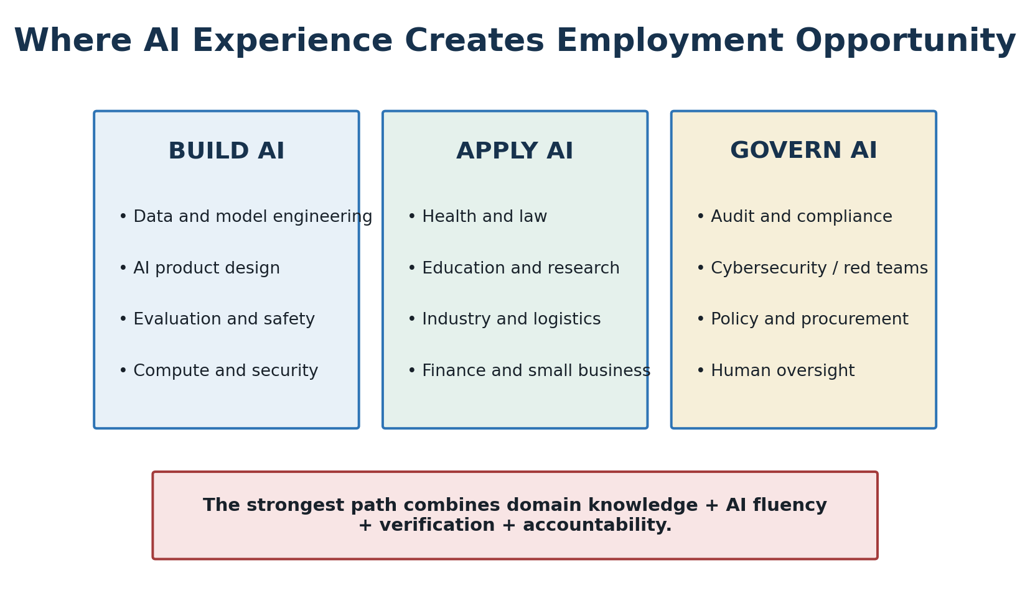
Figure 4. Valuable AI experience includes building systems, applying them within existing professions, and supervising or governing their use.

Employment and professional advancement
AI opportunity is broader than becoming a model engineer. Organizations need people who understand a profession and can identify useful tasks, protect data, design workflows, test outputs, document decisions, manage incidents and preserve human accountability. The largest opportunity may belong to workers who combine domain knowledge with the ability to apply, question, verify and supervise AI.
- Build: data engineering, model evaluation, product design, safety, infrastructure and cybersecurity.
- Apply: AI-enabled work in medicine, law, education, finance, manufacturing, logistics, agriculture, government, media and small business.
- Govern: audit, compliance, procurement, risk management, privacy, red teaming, policy, incident response and appeals.
- Advance: document measurable results, preserve subject expertise, learn verification and translate AI capability into improved human outcomes.

4. Truth, Ethics and Institutional Power
Ethical test: Do not ask only whether an AI system can perform a task. Ask who authorized it, whose interests it serves, what evidence supports it, who bears the risk, and who can challenge the result.

The ethics of AI and the ethics of its experts belong in the same investigation. Researchers, executives, public officials, advocates and critics may offer valuable evidence while also holding financial, political, ideological or institutional interests. Elon Musk is a significant source because he has built and financed AI companies, warned publicly about advanced-AI risks and influenced policy debate. Those experiences make his views relevant, not automatically authoritative; his ownership, competition and political interests must be disclosed and tested like those of every other expert.
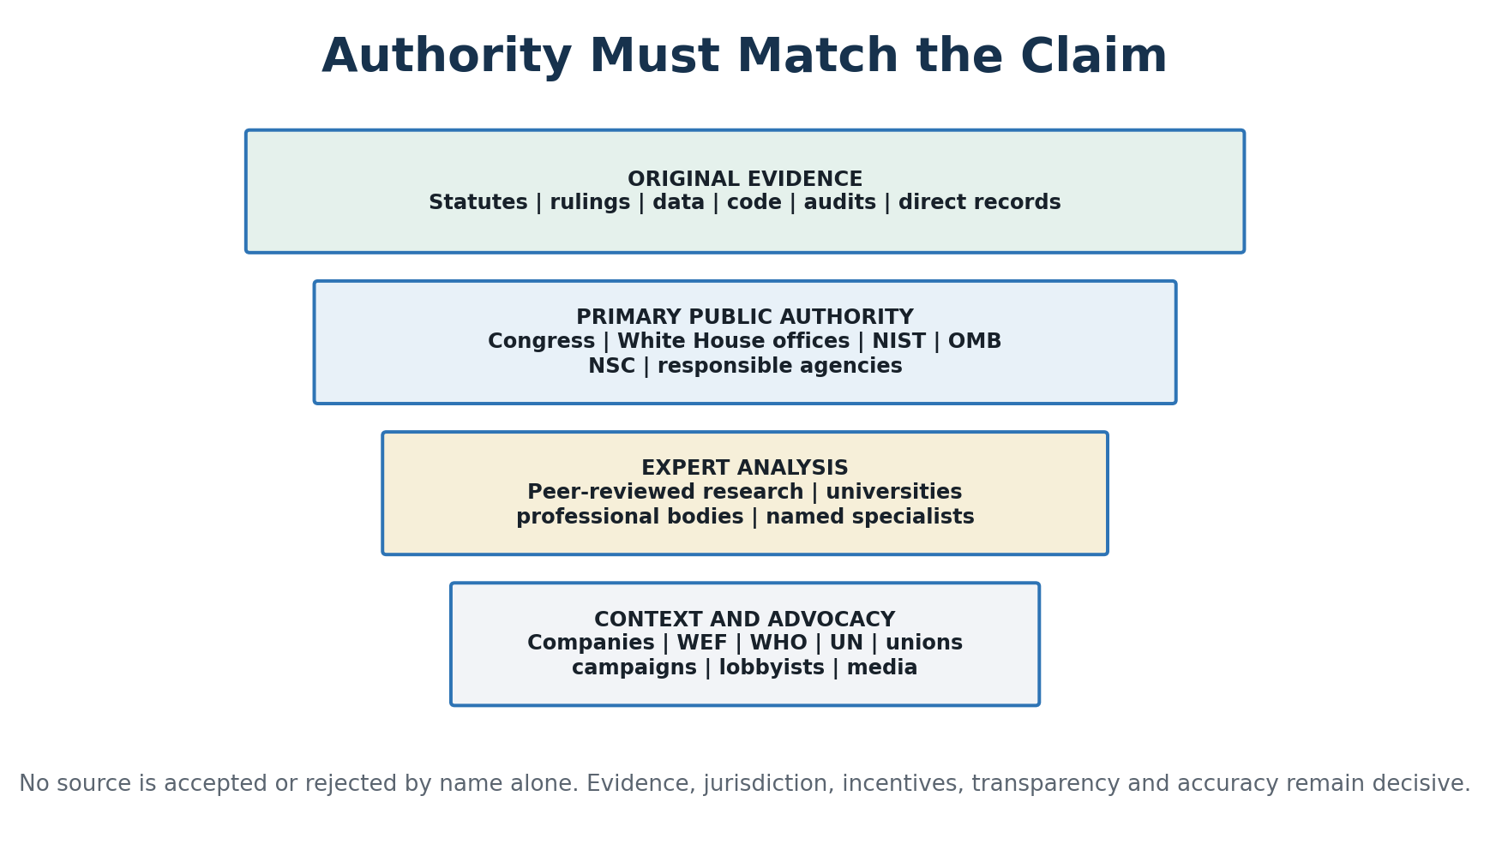
Figure 5. Source authority is claim-specific. A public-health organization may be relevant to health guidance without possessing authority over U.S. constitutional law or national AI policy.

U.S. primary-source priority
For claims about United States law, federal policy, standards, procurement or national security, the investigation prioritizes Congress and enacted law; courts; the White House and Office of Science and Technology Policy; the National AI Initiative Office; PCAST; OMB; the National Security Council and presidential memoranda; NIST; GAO; CISA; NSA; NSF; DARPA; DOE and other agencies within their lawful jurisdictions. A White House statement is authoritative evidence of an administration position, not automatic proof that the policy is effective or lawful.

Institutions that direct AI
Direct institutional power is concentrated among frontier-model developers—including OpenAI, Google DeepMind, Anthropic, Meta AI, SpaceXAI/xAI, Alibaba/Qwen, DeepSeek and Mistral AI—and the chip, cloud, data-center and energy institutions that make large-scale AI possible. National governments set strategy and law; the European AI Office exerts regulatory influence; NIST, ISO/IEC and IEEE shape standards; universities and independent evaluators shape research and measurement; and investors, technology platforms, schools, healthcare systems, financial institutions and government purchasers determine what is deployed.
WEF, WHO and the United Nations occupy a lower or sector-specific tier. WEF is a private convener without sovereign authority; WHO is relevant principally to health applications; and the UN documents international negotiations and member-state positions. Their material may provide evidence and context, but they are not the leading institutions directing AI technology or United States policy.
An institutional accountability vacuum arises when developers, infrastructure providers, deployers, managers and regulators each disclaim responsibility. The investigation must identify who controls the system, who benefits, who can stop or correct it, and who must provide explanation, appeal and remedy when harm occurs.

Facts and truth over time
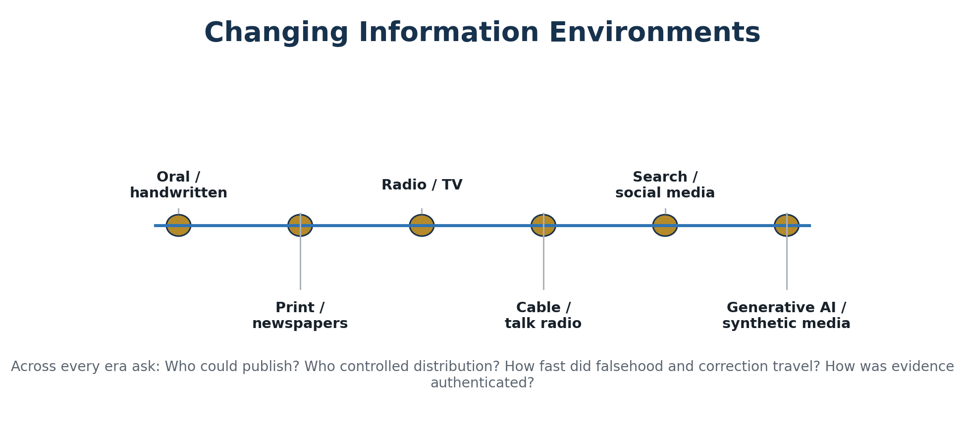
Figure 6. AI is the latest information environment, not the first to expand access while creating new forms of concentration, persuasion and error.
A functioning society needs enough shared factual ground to disagree about values and policy without disputing every underlying event. AI can help translate technical records, compare claims, expose contradictions and search archives. It can also create synthetic evidence, citation laundering, personalized propaganda and a “liar’s dividend” in which authentic evidence is dismissed as fake. Corrections should be studied for speed, visibility, accountability and whether they restore trust—not merely whether they were issued.

5. Threats From and Threats to AI
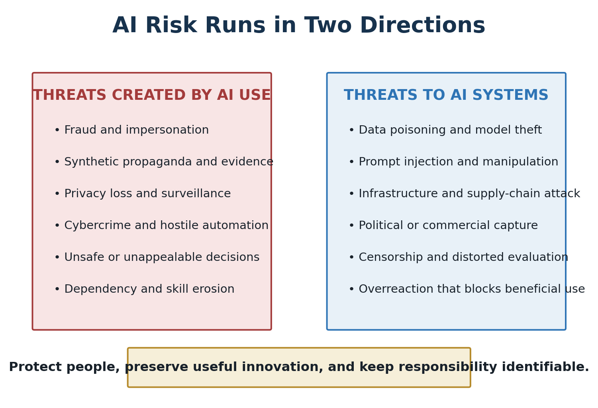
Figure 7. Responsible governance addresses both harmful applications and attacks, capture or restrictions that damage beneficial AI.

Threats created by AI use
- Fraud, impersonation, financial scams, nonconsensual synthetic media and fabricated evidence.
- Cyber operations, automated reconnaissance, malicious code assistance and attacks on critical infrastructure.
- Propaganda, influence operations, censorship, surveillance and manipulation of public belief.
- Biased, opaque or unappealable decisions in employment, credit, healthcare, policing and government benefits.
- Mass-produced low-quality information, privacy loss, intellectual-property conflict and erosion of human skill.

Threats to AI and beneficial development
- Training-data poisoning, prompt injection, model theft, sabotage, espionage and supply-chain compromise.
- Compute, energy and semiconductor concentration that creates fragile dependencies or political leverage.
- Regulatory or corporate capture that protects incumbents, suppresses competition or converts voluntary guidance into opaque control.
- Censorship, ideological manipulation, deceptive evaluation and safety claims that cannot be independently tested.
- Blanket opposition or poorly designed bans that drive use underground, widen unequal access or prevent legitimate medical, scientific, educational and security benefits.

Opposition, advocacy and criminal-use evidence
The investigation includes pause campaigns, labor unions, artists’ and authors’ groups, civil-liberties advocates, businesses, lobbyists and politicians seeking restriction, compensation, consent, transparency or prohibition. “Anti-AI” is not a sufficient category: a demand for worker bargaining rights or protection against nonconsensual replicas is different from opposition to all machine learning. Criminal-use claims must distinguish warnings, vendor reports, allegations, charges, intelligence assessments, convictions and measured losses.

6. AI’s Promise, Productivity and Present Reality
AI can create profound productivity and economic-efficiency gains by reducing routine work, accelerating research, improving access to expertise and helping smaller organizations perform tasks once reserved for large institutions. These gains should be treated as an opportunity for self-improvement and professional advancement. Productivity is most valuable when it frees people to learn, create, serve others, build businesses, improve judgment and perform more meaningful work.
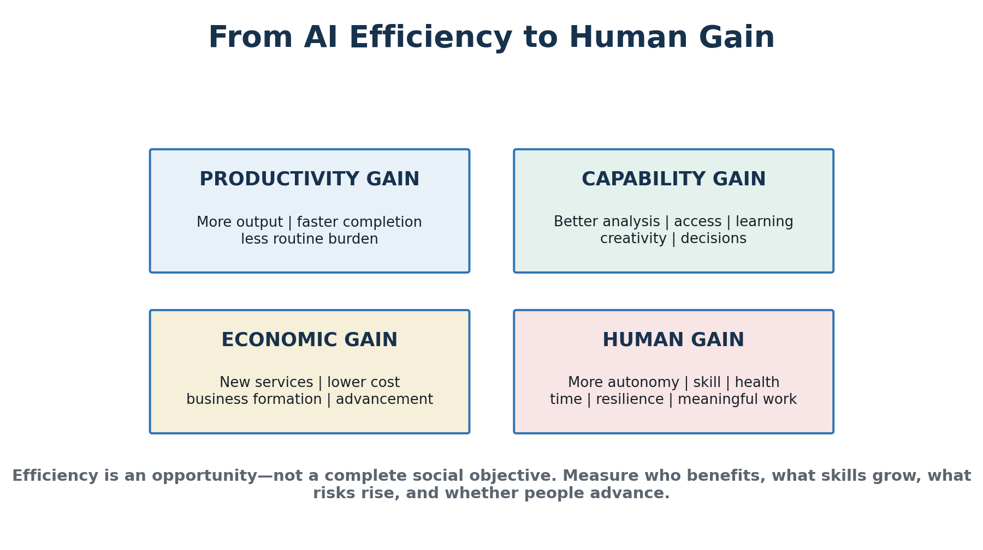
Figure 8. Output and cost matter, but they do not by themselves establish human progress.

Promise versus reality
Promise | Present reality to test | What success should require
Personalized education | Assistance may improve output without durable learning | Retention, transfer, independent reasoning and equitable access
Better healthcare | Strong performance can be narrow and data-dependent | Clinical benefit, safety, privacy, explanation and accountable professionals
Higher productivity | Time savings may become layoffs or intensified workload | Shared gains, skill growth, professional mobility and better services
Democratized expertise | Access can expand while infrastructure power concentrates | Competition, affordability, verification and user autonomy
Safer institutions | Automation can scale errors and create common points of failure | Audit, fallback operations, appeal and resilience
More truth | AI can retrieve evidence and manufacture plausible falsehood | Source integrity, authentication, visible correction and public literacy

Two scoreboards
Machine capability should be measured through accuracy, reliability, speed, cost, reproducibility, security, energy and resource efficiency, robustness and performance against credible alternatives. Human flourishing should be measured through decision quality, knowledge retention, skill, autonomy, privacy, due process, accessibility, distribution of benefit, accountability, trust, relationships and resilience during failure. Improvement on the first scoreboard does not prove improvement on the second.

7. Responsible and Purposeful Human Direction
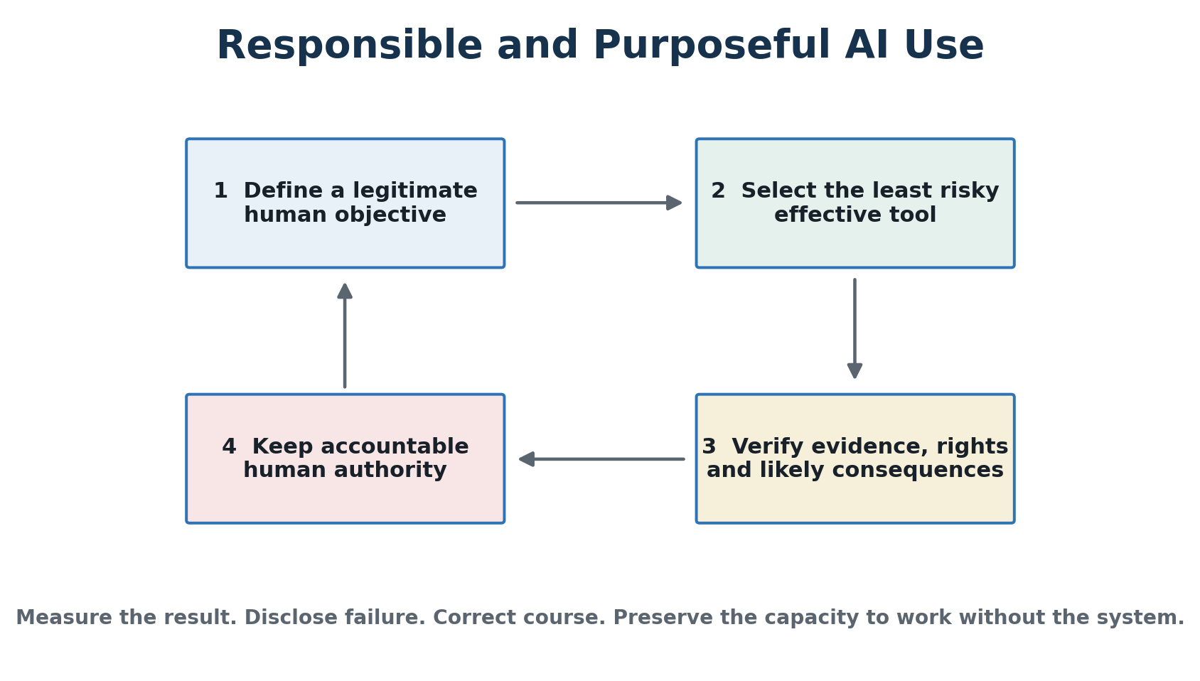
Figure 9. Responsible use controls risk; purposeful use begins with a legitimate human objective and measures whether AI actually improves it.
Actor | Primary responsibility
Individuals | Verify important claims; protect confidential data; preserve foundational skills; ask for counterarguments; retain responsibility.
Parents | Know which systems children use; protect privacy and development; preserve spaces for unaided reading, writing, calculation, play and conversation.
Educators | Teach AI literacy and subject knowledge together; disclose permitted use; assess process and independent mastery; keep teachers in authority.
Businesses | Approve use cases; classify data; assign owners; validate outputs; plan incidents and fallback operations; invest productivity gains in people.
Government | Protect constitutional rights, due process, competition, children, privacy and national security; invest in research, education, energy, chips and expertise.
Developers | Document limits; test foreseeable misuse; secure systems; support audits; disclose material failures; design for human challenge and control.

Human Readiness Board
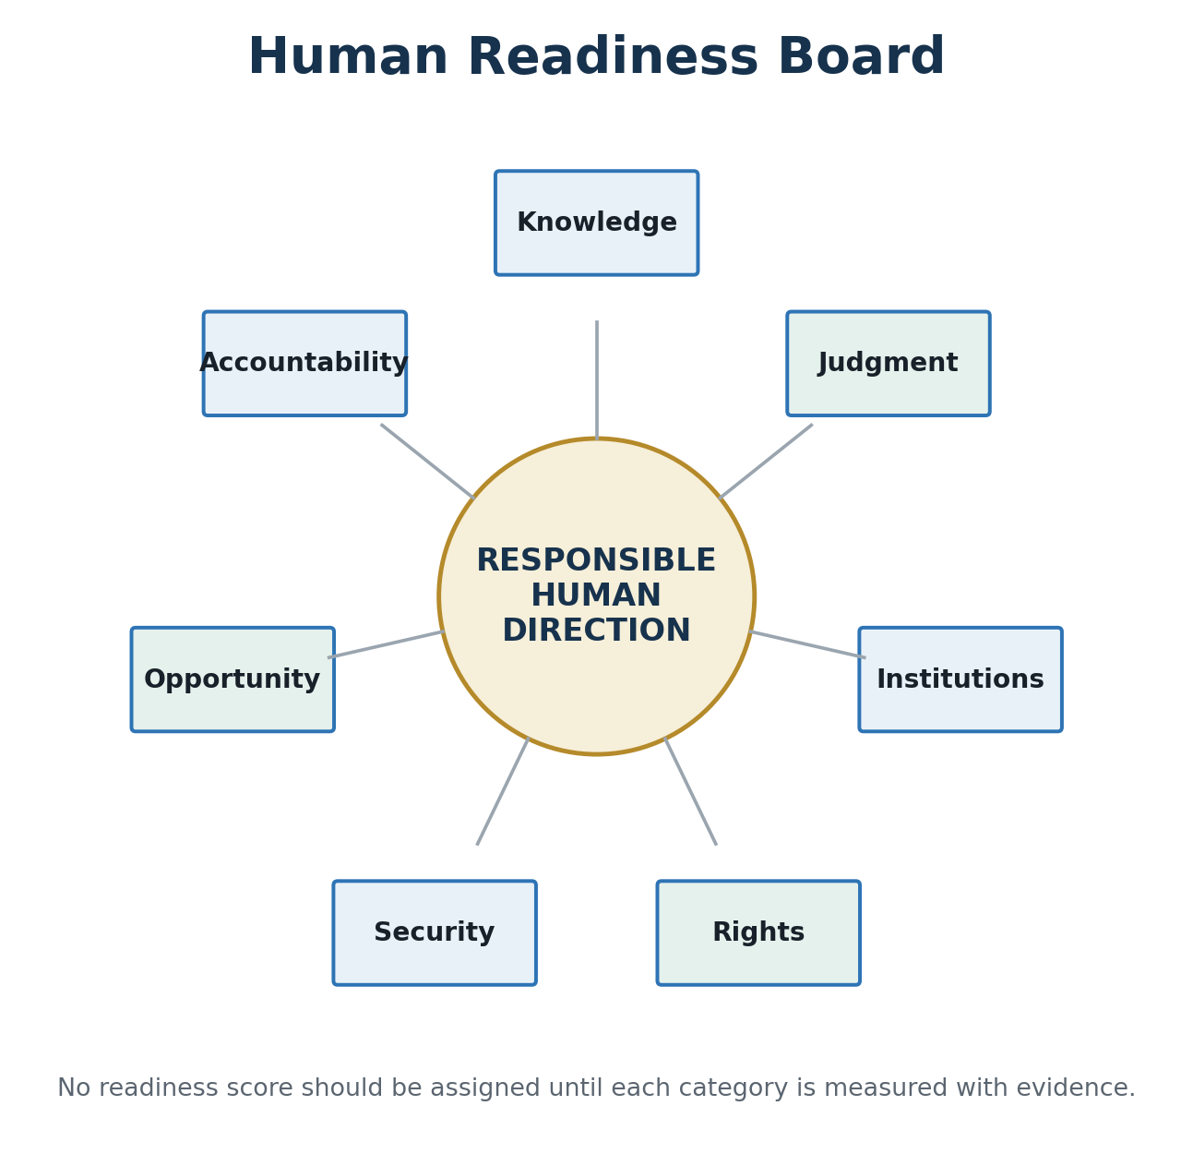
Figure 10. Readiness is not model capability. It is society’s ability to understand, question, secure, govern and benefit from AI.
The board asks whether people understand AI; can distinguish evidence from plausibility; possess trained institutions and fallback procedures; retain rights and appeal; secure systems against manipulation; share opportunity broadly; and identify who is accountable when harm occurs. These dimensions should be measured periodically rather than assumed.

Conclusion
Conclusion: AI should be developed and used responsibly, deliberately and purposefully—as an instrument of examined human judgment, not a replacement for it.

AI’s future will be shaped by the questions people ask, the information systems are permitted to use, the objectives developers reward, the institutions that deploy them, the laws governments enact and the habits society chooses to preserve. The central danger is not only that machines become powerful. It is that humans become intellectually passive, morally evasive or institutionally dependent while confusing generated certainty with wisdom.
The central promise is not automation alone. It is that informed people can use AI to expand knowledge, creativity, health, security, productivity, accessibility and opportunity without surrendering truth, freedom, judgment or human dignity. Children must still learn foundational skills. Professionals must retain the expertise to challenge systems. Citizens must demand original evidence. Institutions must reward correction. Governments must protect liberty, competition, due process and national resilience.
Current AI does not duplicate the full potential of human intellect: it can process information at remarkable scale but lacks human consciousness, lived experience, moral agency and responsibility. This investigation demonstrated the distinction. AI materially assisted research, data collection and analysis, but required substantial human oversight, formation of the argument, writing and editing. Neither the AI nor the author claims perfection; the evidence, transparency and effort should speak for themselves.
The final measure is therefore human: not only what machines can produce, but whether the people and societies using them become more truthful, capable, free, ethical and wise.

Evidence Rules and Selected Source Map
- Prefer original documents, data, code, statutes, regulations, court decisions, audits and direct testimony.
- Distinguish facts, official claims, expert judgments, inference and speculation.
- Match a source’s jurisdiction and authority to the claim being made.
- Separate proposed policy from enacted, implemented and enforced policy.
- Disclose material financial, political, corporate and institutional interests.
- Compare opposing interpretations using their strongest evidence.
- Separate correlation, plausible mechanism, contribution and demonstrated causation.
- Record uncertainty; preserve dated predictions; verify citations; correct errors visibly.
Source family | Examples and role
Philosophy | Aristotle, Nicomachean Ethics; Stanford Encyclopedia of Philosophy on Aristotle’s ethics
U.S. policy and law | Congress.gov and U.S. Code; White House/OSTP; National AI Initiative Office; PCAST; OMB; NSC and presidential memoranda
Standards and accountability | NIST AI Risk Management Framework; GAO AI Accountability Framework; ISO/IEC and IEEE AI standards; CISA and NSA AI security resources
Research | Noy and Zhang; Brynjolfsson, Li and Raymond; Bastani and colleagues; Lee and colleagues; human-AI performance meta-analysis
International context | European Commission and AI Office; OECD/GPAI; Council of Europe; United Kingdom and other national AI-safety institutes; International AI Safety Report
Threat and crime records | FBI, DOJ, Treasury/FinCEN, Europol and ODNI records; company threat reports treated as interested-source evidence
Public trust and history | NORC General Social Survey; ANES; Pew; Gallup; National Archives; Library of Congress

This concise edition is a visual synthesis of the full investigation. It does not eliminate the need to inspect the complete working paper, archived model transcripts and original sources before publication or high-consequence use.

